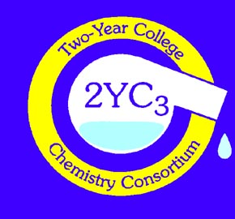
COMMITTEE ON CHEMISTRY IN THE TWO-YEAR COLLEGE
Division of Chemical Education
American Chemical Society

Application for Industrial Sponsorship

Note: Industrial sponsorships are open to any and all stakeholders and supports of chemistry education in two-year colleges as well as vendors, such as textbook publishers, who wish to exhibit at 2YC₃ conferences. Paid sponsorship is required in order to exhibit. Your support helps to ensure the existence and vitality of the 2-Year College Chemistry Consortium (2YC₃) and its three and four regional conferences each year. The conferences provide professional development opportunities for 2-year college chemistry faculty as well as high school and university faculty. The annual sponsorship is $200. You will be notifies when it is time to renew.

Date: __________________________
Your Organization Name:_________________________________________________________
Address:_______________________________________________________________________
City: __________________________________ State:_____________________ Zip:__________ Name of Contact Person: Dr. Mr. Ms. Miss Mrs. ___________________________________
Title: ___________________________________________E-mail: ________________________
Telephone: _____________________________________Ext. ____________________________
Contact Address (if different from above):___________________________________________
What is the nature of your organization? _______________________________________________________________________________
Do you expect to be a regular exhibitor at 2YC₃ conferences? ___________________________

All questions and correspondence concerning 2YC₃ Industrial Sponsorships should be directed to:
Michele Turner E-mail: cmt@uakron.edu
The University of Akron Phone: 330-684-8925
Wayne College Fax: 330-684-8989
1901 Smucker Road
Orrville, Ohio 44667

Please make check payable to: Committee on Chemistry in the Two-Year College and return with this completed application form to Michele Turner at the above address.
(2YC₃ is a tax exempt organization. The Tax I.D. number is 42-0935374)

Or pay online via Paypal: http://www.2yc3.org/isop.htm

