**TABLE OF CONTENTS**

**2YC3 CONFERENCE PLANNING MANUAL** 1

**SITE SELECTION AND APPROVAL OF HOST INSTITUTION** 2

**GUIDE TO PLANNING A 2YC3 CONFERENCE** 3

**RESPONSIBILITIES OF PROGRAM CHAIR** 4

PRE-CONFERENCE PUBLICITY 4

PRE-CONFERNCE ROLE 4

CONFERENCE ROLE 6

POST-CONFERENCE ROLE 6

COMUNICATION WITH THE NEWSLETTER EDITOR 6

PREPARING MATERIALS FOR THE NEWSLETTER 7

**RESPONSIBILITIES OF LOCAL ARRANGEMENTS CHAIR** 8

FACITLITIES 8

PRE-CONFERENCE ROLE 9

CONFERENCE ROLE 10

POST CONFERENCE ROLE 11

FINANCING A CONFERENCE 11

**RESPONSIBILITIES OF EXHIBITS COORDINATOR** 13

PRE-CONFERENCE ROLE 13

CONFERENCE ROLE 14

POST-CONFERENCE 14

**PREPARING A CONFERENCE WEBSITE** 15

**CONFERENCE TIMELINE/CHECKLIST** 16

**CONFERENCE ADVICE** 18

**2YC3 CONFERENCE PLANNING MANUAL**

Dear Conference Organizer:

The Committee on Chemistry in the Two-Year College (COCTYC) wishes to thank you for your support in planning and conducting a conference. This conference planning guide is a distillation of information and suggestions prepared by COCTYC Chairpersons, members of the Committee, and past conference organizers.

We encourage you to contact any member of the COCTYC any time you need information or assistance. The names, addresses, and phone numbers of the Committee members are listed on the front cover of every newsletter. The COCTYC wishes to do everything possible to assist you in conducting a successful conference. Toward that end, the Committee conducts occasional conference planning workshops, and also supports an active conference "mentoring" program whereby an experienced conference planner in your area visits your college and consults with you on the planning of your conference.

Past newsletters can be extremely valuable as models for programs (preliminary and final) and local arrangements (lodging, travel directions, transportation, conference maps, etc.). A preliminary announcement, which can be distributed as an advance "advertisement" at meetings prior to your conference, is highly recommended.

You will be notified by the Newsletter Editor and/or the COCTYC Chairperson for the year of your conference with regard to the specific deadlines for newsletter material. Please keep in mind that because of the lead time necessary for preparing, printing, and mailing the newsletter, a copy is due approximately four to five months prior to the actual conference. It is absolutely essential that you adhere to the newsletter deadlines.

We encourage suppliers and publishers to become Industrial Sponsors, and also to advertise in the newsletter. Please refer your company representatives to the Industrial Sponsors Chair and the Assistant Industrial Sponsors Chair, who is in charge of newsletter advertising.

If you know of others who would be interested in hosting a future meeting, please put them in contact with the future sites coordinator, [futuresites@2yc3.org](mailto:futuresites@2yc3.org).

Sincerely,

COCTYC

**SITE SELECTION AND APPROVAL OF HOST INSTITUTION**

**Site Selection**

In general, our conference sites need to be in areas that:

1. Are near, or served by, an airport with good direct or connecting service that permits decent access to the site by attendees who come from all areas of the country.
2. Have good (nice) reasonably priced motels.
3. Have good, reasonably priced transportation between the airport and the motel area, as well as between the motel area and the college. Sometimes the college is able to assist in the latter by providing a van or bus.

**Approval of Host Institution**

It is extremely important that you get approval, in writing, from your top administration, and that they know what is involved. Most Presidents, Deans, etc., readily agree to host national conferences such as ours. However, we generally schedule about 2-3 years in advance, and individuals and circumstances change. It is important for all involved to state dates, facilities, and financial commitments in writing.

**Facilities**

The host institution:

1. Provides lecture rooms, classrooms, laboratories or conference rooms as required for various aspects of the program, workshops, committee meetings, etc. These vary with the program of each conference but are generally:
   1. General meeting room (capacity 100-150), parts of Friday and Saturday for keynote presentations and membership meetings.
   2. Two - four rooms (capacity 25-50), parts of Friday and Saturday for break out parallel presentation sessions.
   3. Areas and facilities for registration, refreshments, and exhibits, as close together as possible. Exhibit and refreshment areas need to be near each other to promote traffic through the exhibit area. Exhibit materials must have adequate security for overnight storage.
2. Adequate notice and help from information technology and maintenance staff for the conference. Remember, many of these people will not normally work on the Saturday of the conference.

**Financial**

The host institution:

1. Covers the cost of the printing of programs and other materials, signs directing attendees and exhibitors, etc.
2. Covers the operational costs of planning and executing a conference such as secretarial time, phone calls, maintenance and custodial operations, etc.
3. Receives all profits from the conference.

A letter of support from a top administrator ([sample commitment letter](#sampleletter)) and a [conference income statement](#conferenceincome) should be send to the current chairperson of COCTYC.

**GUIDE TO PLANNING A 2YC3 CONFERENCE**

As soon as the Program Chair, Local Arrangements Chair and Exhibits Coordinator are selected, they should meet to discuss the availability of appropriate facilities, technology services at the conference site for presentations, workshops, exhibits, registration.

At times, 2YC3 conferences have been held jointly with a state chemistry association or regional ACS meeting. Such joint efforts offer potential for increased attendance, as well as the combined resources and support of both organizations in executing the program.

The goals of the program for a conference are (1) to appeal sufficiently to the interests and needs of a large number of two-year college chemistry teachers, to encourage them to attend the conference, and (2) to insure that they are not disappointed if they attend. Conferences are for their professional development.

Although many programs have been organized around a single major theme, it is not necessary to have a major theme. The program should involve a variety of topics which will appeal to wide range of attendees.

Friday is mainly devoted to registration, visiting exhibits, a keynote speaker, and the 2YC3 general membership meeting. Parallel presentation sessions, workshops, discussions, poster sessions, and tours can begin the latter part of Friday morning and continue throughout Friday afternoon. A social event usually occurs on Friday evening. Saturday morning usually begins with a featured speaker. Parallel presentation sessions, workshops, discussions, poster sessions, and tours can begin after the features speaker and continue throughout Saturday afternoon. Most conferences end between 3:00 – 5:00 p.m.

Workshops are an excellent attraction for attendees. They offer faculty members an opportunity, in a half-day session, to learn about a technique or teaching approach which can be incorporated into their curriculum. Skilled workshop directors are often available from area universities, as well as manufacturers or suppliers of instruments and computer hardware and software. Our Industrial Sponsors have often been quite helpful in this regard.

It should be noted that exhibits are considered to be a significant part of the conference from the standpoint of our attendees. For their benefit, and in return for the support of our Industrial Sponsors, it is important to encourage visiting the exhibit area. It is therefore necessary to allow sufficient time for this purpose during the conference.

Subsequent pages in this manual will contain more detailed information and lists of responsibilities for each of the three conference chairpersons. It is important that adequate communication be maintained between the three chairpersons throughout the entire conference planning process.

**RESPONSIBILITIES OF PROGRAM CHAIR**

The main function of the Program Chair is to put the program together. S/he must select the speakers for the program, decide if there are going to be any workshops or tours, and arrange for these. The following check-list will assist in the planning.

**PRE-CONFERENCE PUBLICITY**

1. Eight months before the date of the conference, send flyers and/or emails to two/four-year college chemistry departments and high schools in the conference site region, informing them of the conference and asking for paper presenters. Send your flyers and email messages to your conference mentor and they ensure 2YC3 sends these items out through our databases and social media sites.
2. 2-3 months before the conference, prepare another reminder flyer/email. 2YC3 will send it out on your behalf.
3. Distribute flyers at state and local science meetings.
4. Attend several 2YC3 conferences prior to your conference, and distribute flyers. If this is not possible, send flyers to the conference planners to distribute.

**PRE-CONFERENCE ROLE**

1. A mentor has been assigned for your conference. Contact the Chair or Future Sites Coordinator if you do not know your assigned mentor.
2. Along with the other conference chairs, select a conference theme(s) that will attract a variety of participants. Consult 2YC3 newsletters for previous themes and programs.
3. Send the Newsletter Editor a "Call For Papers" for the 2YC3 Newsletter. Check newsletter deadlines!
4. Identify possible presenters from:
   1. Two-year colleges
   2. Four-year colleges/universities
   3. Federal/state/local government agencies
   4. Industry
   5. Regional high schools
   6. past speakers from local ACS meetings
   7. Use listservs, social networking sites, or other electronic media for suggestions.
5. Screen and select papers.
   1. Avoid selecting papers that are solely advertisements for products. Many exhibitors wish to make presentation, but encourage them to do an educational presentation not a product placement ad. Have exhibitors recruit an instructor to talk about the product rather than the sales rep.
   2. At first, you will have a slow response to the call for papers. Do not get too anxious! The slots will fill as the conference approaches.
6. Select discussion panels, workshops, and/or tours.
7. Contact each speaker and presenter regarding their media needs and their day and time preferences, while also requesting an abstract of their presentation. ([email template](#presenteremail))
8. Communicate with the Newsletter Editor regarding submissions for program announcements in the 2YC3 Newsletter.
9. Periodically meet with or contact the Local Arrangements Chair and Exhibits Coordinator to review progress and discuss mutual problems.
10. Prepare a preliminary and a final program. The final program should indicate times and rooms for papers, workshops, and meetings. ([conference program template](#program))
11. Exhibits are an essential part of the conference. Leave enough time gaps (30 minutes) so that the attendees can visit the exhibits.
12. Include as many community college teachers as feasible in the program. Quite often, having a part in the program will encourage attendance and enable the individual to secure travel funds from their institution.
13. Select individuals to chair various sessions of the conference.
    1. These individuals will introduce speakers and keep the program running on-time.
14. Contact the webmaster ([webmaster@2yc3.org](mailto:webmaster@2yc3.org)) to set-up your registration site.
15. Work with the local arrangements chair to prepare a registration folder for all attendees, including exhibitors. Please include the following items in the folder.
    1. Final [program](#program) with location and times for all presentations, workshops, tours, exhibits, and refreshments.
    2. [Name tag](#nametag).
    3. Parking permits (if needed).
    4. A list of pre-registered [attendees with contact information](#attendeelist).
    5. [Campus maps](#campusmap) and [directions/maps](#map) to the hotels, social event, tours, etc.
    6. Tickets for pre-paid lunches and banquets
    7. If the attendee sent ***you*** a check, include a signed [receipt](#receipt) for paid registration, lunch, and other fees. ***Note: Most attendees will pay through PayPal or send their check to the membership chair; therefore, they will not need a receipt.***
    8. Pen and notepad (or several sheets of paper).
    9. A flyer indicating the [upcoming 2YC3 conferences](#futuremeetings).
    10. A listing of the current [2YC3 officers](#officers).
    11. Handouts for the general membership meeting. Request these handouts from the chairperson a week before the conference.
    12. Information about your college and local attractions.

**CONFERENCE ROLE**

1. Preside at the Conference.
2. Keep the program on schedule.
   1. Sessions should begin promptly, and speakers must complete their presentations in the allotted time. Clearly state the time limits to all presenters.
3. Make announcements and encourage attendees to visit the exhibits.
4. Meet with COCTYC members for conference debriefing.
   1. Provide attendance figures.
   2. Provide number of exhibits and if any new sponsors were recruited.
   3. Provide comments about the hosting process.

**POST-CONFERENCE ROLE**

1. Send an email to all attendees with a link to the conference survey. The survey is done through SurveyMonkey. Your conference mentor will provide to the link to you and also share the survey results.
2. With the sigh of relief that undoubtedly comes after getting through the conference, it is all too easy to forget about acknowledging the services of those people who were instrumental in planning and conducting the meeting. However, it is most important to thank these people, as the success of the meeting depended on them. A list of people to thank, together with suggested forms of acknowledgment, is given below:
   1. The secretarial staff that was involved in the planning, correspondence, arrangements, etc., deserves special recognition.
   2. Duplication, IT, publicity, graphic arts, custodial, and other support personnel at your institution. Memoranda of commendation to the appropriate supervisor(s), together with a copy to the individual, are most appropriate.
   3. The President of your institution will receive a thank you letter from the COCTYC Chair for hosting the conference. However, if the President, or any other officer or your school, has been particularly supportive or helpful to you in your role as program chair of the meeting, it would be appropriate for you to write a personal letter of appreciation.
   4. Program Participants - Presenters, workshop directors, moderators or discussion leaders, session chairpersons, etc., should all be sent individual thank-you letters by the program chairperson for their contribution to the program. If you wish, and have the facilities at your print shop, you could prepare certificates of appreciation which can be sent with the thank-you letter. The letter and certificate could also be sent to any other individuals whom you feel made a significant contribution to the program.

There may well be other individuals, not included in the above list, who deserve to be thanked. It is up to you, as chairperson of the meeting, to convey your appreciation to everyone who contributed to the success of the conference.

**COMMUNICATION WITH THE 2YC3 NEWSLETTER EDITOR**

The conference program chair is expected to submit newsletter materials to the Newsletter Editor. A [call for papers](#callforpapers) and a [program announcement](#newletterannouncement) must be submitted at the direction of the Editor. These materials should be submitted via an e-mail attachment.

**RESPONSIBILITIES OF LOCAL ARRANGEMENTS CHAIR**

While the Program Chair is working on his/her activities, the Local Arrangements Chair should make preliminary arrangements for facilities. The basic facilities that are needed for a 2YC3 conference are:

1. **A GENERAL SESSION ROOM**

Requires one auditorium type room that will accommodate about 100-150 people. In case of possible high attendance, a larger room may be required. A lectern and microphone plus facilities for all types of media might be necessary. Please double check to insure that all necessary equipment is present and in proper working order and have a knowledgeable person on standby to render assistance, if necessary. This room can also be used for the General Membership meeting on Friday.

1. **AN EXHIBITS AREA**

Requires a large space (conference room, foyer, open laboratory, empty room, etc.) where 10-20 exhibitors may set up displays. Tables 2-3 feet wide and 5-6 feet long are required. Some exhibits may require electricity and/or water. Each exhibitor will send requirements directly to the Exhibits Coordinator. **The exhibits area should contain the refreshment and seating areas.** If possible, the exhibits area should also be convenient to the general session meeting room. Exhibit materials must also have adequate security for overnight storage. Below is a map of a conference site where the exhibits, refreshments, and lunches were all served in one room. A room with about 2000 sq ft is usually large enough to accommodate exhibits and food.

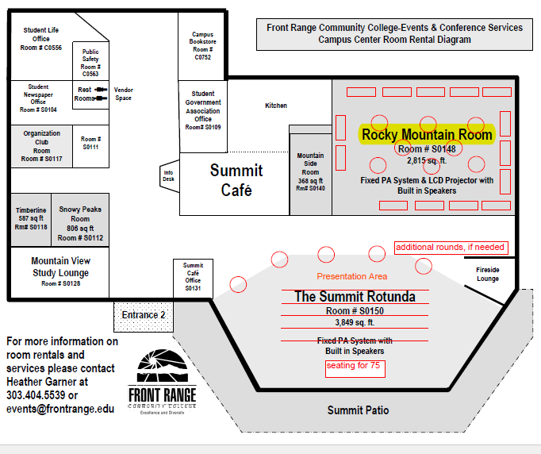

1. **A REGISTRATION AREA**

Requires one or two registration tables manned by two to four people, depending on how busy it is. It should be located in or near the exhibits area and, if possible, near the entrance to the general session meeting room. This should also serve as an information desk.

1. **A REFRESHMENT AREA**

This usually includes coffee, tea, juice, donuts, rolls, cookies, etc., as appropriate ([209th Friday menu](#catering)). It is **important** that the refreshment area be **located in the exhibits area**. If possible, it should also be convenient to the general session room. Ask exhibitors if they wish to contribute to or supply the refreshments.

1. **PARRALEL PRESENTATIONS, WORKSHOPS, AND DISCUSSION GROUPS**

Require classrooms with a capacity for about 25-50 people.

1. **A Social Event**

In the past, an evening banquet and speaker has occurred on Friday night. This a great way for attendees to socialize over dinner. While this is a fun event, the cost of holding a banquet has increased significantly over the last few years. Often the price for attending the banquet cost more than the registration fees. Our committee encourages some type of Friday evening social event. This event still could be a banquet at a restaurant or the college. It also could be a happy hour event at a local restaurant, a tour of a local attraction, or just a list of local restaurants. Some conferences have had events at science museums, boat cruises, etc. The options are endless. Hosting a banquet does require more of a commitment and money would need to be collected at the time of registration. Other events may need people to pre-registration if space is limited, but money does not need to be collected at the time of registration. Attendees could pay when they arrive at the event.

1. **ROOM FOR THE COCTYC MEETING**

Requires one conference room for about 12 people. This room or area is needed for the COCTYC meeting after the conference is over, for a three hour period. If your meeting immediately precedes the spring ACS meeting, a room needs to be reserved all day for the Thursday before the start of your conference. The meeting room can be on campus or make arrangements with one of the conference motels for a **complimentary** room.

**PRE-CONFERENCE ROLE**

Once the meeting areas have been identified, the Local Arrangements Chair should:

1. Clear the use of all facilities required and services needed for dates of the conference with campus administrators. Confirmation in writing is highly desirable.
2. Work with the program chair to submit the local arrangement information with the [program announcement](#newletterannouncement) to the newsletter editor by the due dates.
3. Periodically contact Program Chair and Exhibits Coordinator to discuss progress.
4. Contact local hotels regarding prices for accommodations for conference attendees. DO NOT BE AFRAID TO NEGOTIATE!
   1. Consider the location and convenience of the hotel.
      1. The hotels selected must be easily accessible to both the airport and the college.
      2. Your conference mentor can offer an opinion on the available hotels.
   2. Give the conference participants a choice of hotels if possible.
      1. Most conference planners provide a list of two or three possibilities.
      2. Be sure to reserve a **courtesy block** of rooms for the conference at each hotel for Thursday through Saturday evening.
      3. Provide reservation deadlines, discount codes, and taxes in the newsletter and website.
   3. Attendees might search for hotel deals on their own. It is a good idea to list area neighborhoods where people should search. This is important especially if the conference is held in a large metropolitan area.
5. When hotels are selected, inquire about shuttle transportation to the airport and the college.
6. Contact the webmaster ([webmaster@2yc3.org](mailto:webmaster@2yc3.org)) to set-up your registration.
7. Prepare a welcome packet for attendees to receive at the conference hotels. You may wish to include the following information.
   1. Direction and a [map from the hotel to the campus](#maptocampus).
   2. Parking instructions and a [campus map](#campusmap).
   3. [Dining and entertainment information](#restaurantguide).
   4. A [program summary](#programsummary) sheet.
8. Identify a Friday evening social event. Make reservations or arrangements for tours. If hosting a banquet, pay attention to price per person ($30-$45 is typical) and minimum number required. BEWARE OF THE HAZARDS IN GUARANTEEING MINIMUM NUMBERS!
9. Prepare signs for directing conference attendees to the correct parking lots and then from the parking lots to the registration area and various sessions.
10. Work with the program chair to prepare a registration folder for all attendees, including exhibitors. Please include the following items in the folder.
    1. Final [program](#program) with location and times for all presentations, workshops, tours, exhibits, and refreshments.
    2. [Name tag](#nametag).
    3. Parking permits (if needed).
    4. A list of pre-registered [attendees with contact information](#attendeelist).
    5. [Campus maps](#campusmap) and [directions/maps](#map) to the banquet facility, and hotels.
    6. Tickets for pre-paid lunches and banquets
    7. If the attendee sent ***you*** a check, include a signed [receipt](#receipt) for paid registration, lunch, and banquet fees. ***Note: Most attendees will pay through PayPal or send their check to the membership chair; therefore, they will not need a receipt.***
    8. Pen and notepad (or several sheets of paper).
    9. A flyer indicating the [upcoming 2YC3 conferences](#futuremeetings).
    10. A listing of the current [2YC3 officers](#officers).
    11. Handouts for the general membership meeting. Request these handouts from the chairperson a week before the conference.
    12. Information about your college and local attractions.
11. Work with your college’s business office and set up an account for the deposit of registration and banquet money. (See section on "FINANCING A CONFERENCE".)
12. On the night prior to the conference, post all signs and directions on campus.

**CONFERENCE ROLE**

1. On the morning of the first day of the conference, assign several persons to the registration desk.
2. Assist Program Chair in conducting the conference. Make any necessary announcements about local transportation or other arrangements for the conference.
3. Meet with COCTYC members for conference debriefing.
   1. Provide attendance figures.
   2. Provide number of exhibits and if any new sponsors were recruited.
   3. Provide comments about the hosting process.

**POST-CONFERENCE ROLE**

1. Work with your college’s business office to pay the bills.
2. Send a letter of appreciation to all those who gave you significant assistance in preparing for and conducting the conference. Consider members of your local arrangements committee, administrators, secretaries, and staff members (personnel in duplication, audio-visual, custodial, departments, etc.) at your college, donors of funds, refreshments or equipment, etc.

**FINANCING A CONFERENCE**

1. SETTING UP ACCOUNTS
   1. Work with business office at your school.
      1. Set up expense accounts.
      2. Set up income account.

**or**

* 1. Set up your own checking account.
     1. DO NOT use the account name of 2YC3; instead use "YOUR NAME/2YC3."
  2. Keep good records.
  3. Send a [financial statement](#conferenceincome) to the 2YC3 Chair and Treasurer.

1. **INCOME SOURCES**
   1. Seed money from 2YC3. These are limited funds which can be used only for certain functions. It is expected that seed money be repaid to 2YC3 from monies collected from authorized Conference registration fees.
   2. Registration fees collected by the host institution:
      1. The COCTYC authorizes a $50.00 registration conference fee for full-time instructors.
      2. The COCTYC authorizes a $25.00 registration conference fee for adjunct instructors.
   3. New 2YC3 members and members renewing their dues may submit membership fees.
      1. Presently the COCTYC authorizes a $25 membership fee. All attendees must be members of 2YC3.
   4. Banquet and luncheon fees
      1. Charge enough to cover the costs of meals, snacks, beverages, and some of your smaller expenses.
   5. Donations from Industrial Sponsors
      1. Many industrial sponsors will donate money for refreshment breaks.
      2. Post signs in the refreshment area thanking the sponsors for their donation.
   6. External Funding
      1. Check to see if your college or state system offers grant money for hosting a discipline conference.
2. **COLLECTION OF MONEY**
   1. In an effort to effectively handle registration, COCTYC will collect all money for registration, membership, and meal fees and send checks to the local arrangements chair on a regular basis.
      1. Conference registration is done through the 2YC3 website. Contact the [webmaster](mailto:webmaster@2yc3.org) to set-up the registration site.
      2. Fees are collected by credit/debit card through PayPal or checks are sent to the treasurer. *Please note: PayPal does charge a small fee per transaction. Attendees will pay $50 for registration, but you will receive slightly less money. Please contact the treasurer for more information about the PayPal fee structure.*
      3. Contact the [treasurer](mailto:treasurer@2yc3.org) to determine how often you would like to receive money collected from registration.
3. **EXPENSES**
   1. Pay all bills as soon as possible.
4. **PROFIT**
   1. The college can keep the money for their general fund.
   2. Use this for the betterment of your department.
   3. If enough money is left over, you may want to establish a chemistry department scholarship through your college’s foundation, or to find some other ways to use the money to help students.

**RESPONSIBILITIES OF EXHIBITS COORDINATOR**

**PRE-CONFERENCE**

1. Periodically contact Program Chair and Local Arrangements Chair to discuss progress.
2. Contact the Local Arrangements Chair and appropriate campus administrators regarding the availability of exhibit area and tables for dates of the conference.
3. Obtain a list of 2YC3 Sponsors from the COCTYC Industrial Sponsors Chair, and email a [letter](#sponsorinvitation) to the regional representative in the area, alerting him/her of the conference and its dates.
4. Request recruiting [packets](#sponsorinvitation) from the COCTYC Industrial Sponsors Chair, [industrialsponsors@2yc3.org](mailto:industrialsponsors@2yc3.org), and recruit new sponsors from the local area of the conference site.
   1. New sponsors must pay a $200 fee, which is collected by the 2YC3.
      1. The money from each new sponsor is split equally between the college and 2YC3. (2YC3 pays $100 to the college for each new sponsor and to help defray the cost of the conference.)
   2. Local sponsors have the option of paying $100 to exhibit at only this conference.
      1. All the money from a local sponsor is kept by the host college.
5. Contact the webmaster ([webmaster@2yc3.org](mailto:webmaster@2yc3.org)) to set-up the Exhibitor registration site.
   1. Current Industrial sponsor do not pay any exhibit or registration fees for the conference.
   2. All exhibitors must pay for meals at the conference.
   3. Request sponsorship donations for refreshment or sell advertisement space in the program booklet.
6. Arrange for a locked room to store books and other materials for exhibit. Some exhibitors will send materials prior to the conference.
7. Receive requests from exhibitors and work on layout of exhibit area. Some exhibitors will request electrical outlets.
8. Email [exhibit confirmation letters](#exhibitconfirmation) to exhibitors. Include directions to the college along with specific instructions on where to ship items.
9. Make arrangements for appropriate refreshments to be set up in the exhibit area on the morning of both conference days and during the coffee breaks. The Local Arrangements Chair needs to include the cost of refreshments in the financial arrangements for the conference.
   1. Industrial sponsors frequently donate money for refreshments; your contacts with the exhibitors can be of assistance in this regard.
10. Tables for exhibits should be set up and in place the day prior to the conference. Material shipped prior to the conference should be placed under the respective exhibitor's table. A registration packet and name plate should be placed on the table.
11. Make sure the exhibit area has adequate security for overnight storage**.**

**CONFERENCE**

1. Laboratory carts or similar equipment should be available to help exhibitors transport exhibit material.
2. During the conference, encourage attendees to visit the exhibits. Remind the Program Chair to make such announcements at the beginning of each session. It helps greatly if the exhibit area is easily accessible to the rooms where papers are presented.
3. Periodically check the exhibit area and talk to exhibitors to see if everything is going well. This is an excellent opportunity to enhance relations with our Sponsors. Take care of problems as they arise.
4. Hold a raffle with ticket stubs obtained by attendees as they visit each exhibit. Exhibitors and sales representatives of your suppliers are usually quite willing to donate books or equipment for raffle prizes.
5. Meet with COCTYC members for conference debriefing.
   1. Provide attendance figures.
   2. Provide number of exhibits and if any new sponsors were recruited.
   3. Provide comments about the hosting process.

**POST-CONFERENCE**

1. Ensure all materials are returned to the exhibitor.
2. Write thank you notes to the exhibitors.

**PREPARING A CONFERENCE WEBSITE**

You should prepare a website to publicize your conference. If internal help is not available at your institution, the 2YC3 webmaster will be able to provide some assistance. You may also consider using social networking sites for your conference. The following items should appear on the website:

1. **Program.** Start with a preliminary program and update as more speakers are secured. Abstracts should be included. Other information such as contact information or a short bio may also be included.
2. **Registration Information.** The webmaster will put together an online registration form that enables you to track registrations.

1. **Lodging Information.** Include phone numbers and/or links to the hotel website along with any codes that may be used to reserve at a discounted rate.
2. **Directions.** Include directions from the airport, to the hotels, to the college, and any other directions that may benefit someone that is not from the area. Online maps from various websites should be included.
3. **Campus Map.** Upon arrival to campus, participants should know where they are going. Campus maps should clearly show the building where meetings are located. Room locations should also be shown if the meeting rooms are not all in the same vicinity.
4. **Air Travel Information.** Clearly state what airlines serve your city and the airport(s) that would be most convenient. Also give clear directions from the airport to the hotel in the event that someone chooses to rent a car. These directions should be in written form as well as indicated on the map.
5. **Ground Transportation.** Please explore the options of those who will need transportation to and from the airport. In some cases, the hotels provide transportation. In other cases, a limousine service or other form of public transportation may be useful. The information provided to the newsletter should clearly delineate the possibilities and/or the most recommended method of ground transportation between the airport and the hotel. Such information should also provide the cost and the time involved. If car rental is available, information regarding rental companies and rates may be useful. Besides the map, it is important to spell out the directions between the airport, major routes, hotel, and college.
6. **Examples.**

<http://windward.hawaii.edu/2yc3/2yc3/program.html>

<http://www.roch.edu/people/jjadin/209%20files/209.html>

<http://uwc.edu/depts/chemistry/2yc3>

**CONFERENCE ADVICE**

* Attend a 2YC3 regional meeting before planning a meeting.
* Follow the program template. There is room for some modifications, but make sure you leave enough time for attendees to visit exhibitors during the breaks. The general membership meeting must be held when no other activities are occurring.
* Keep the program on-time! Make the presenters aware of the time limits and have the moderators enforce these time limits.
* Start recruiting speakers nine months before theconference.
* Contact the Industrial Sponsors at least two times by email and phone, if possible.
* Use a variety of presentation formats in your program. Include workshops, discussion panels, poster sessions, and tours. Get local community college faculty to participate in the panel.
* Encourage attendees to see exhibiters by offering raffle prizes for those which visit each booth.
* Make sure there are a variety of topics to attract a good cross-section of attendees.
* Schedule out-of-state speakers to increase the number attending the conference.
* Make frequent and timely contacts with local community colleges and high schools.
* Exhibits Coordinator should make available to the Program Chairperson information about Industrial Sponsors who wish to give talks, as well as exhibit.
* Invite college administrators to address the audience on a few occasions; this will provide access to administrative support.
* Ask exhibitors for financial support to provide refreshments and/or complimentary lunch.
* Set-up exhibit booths in a location where the refreshments and lunch can also be located. Have empty table and chairs available so attendees will be close to the exhibitors and more likely to visit them.

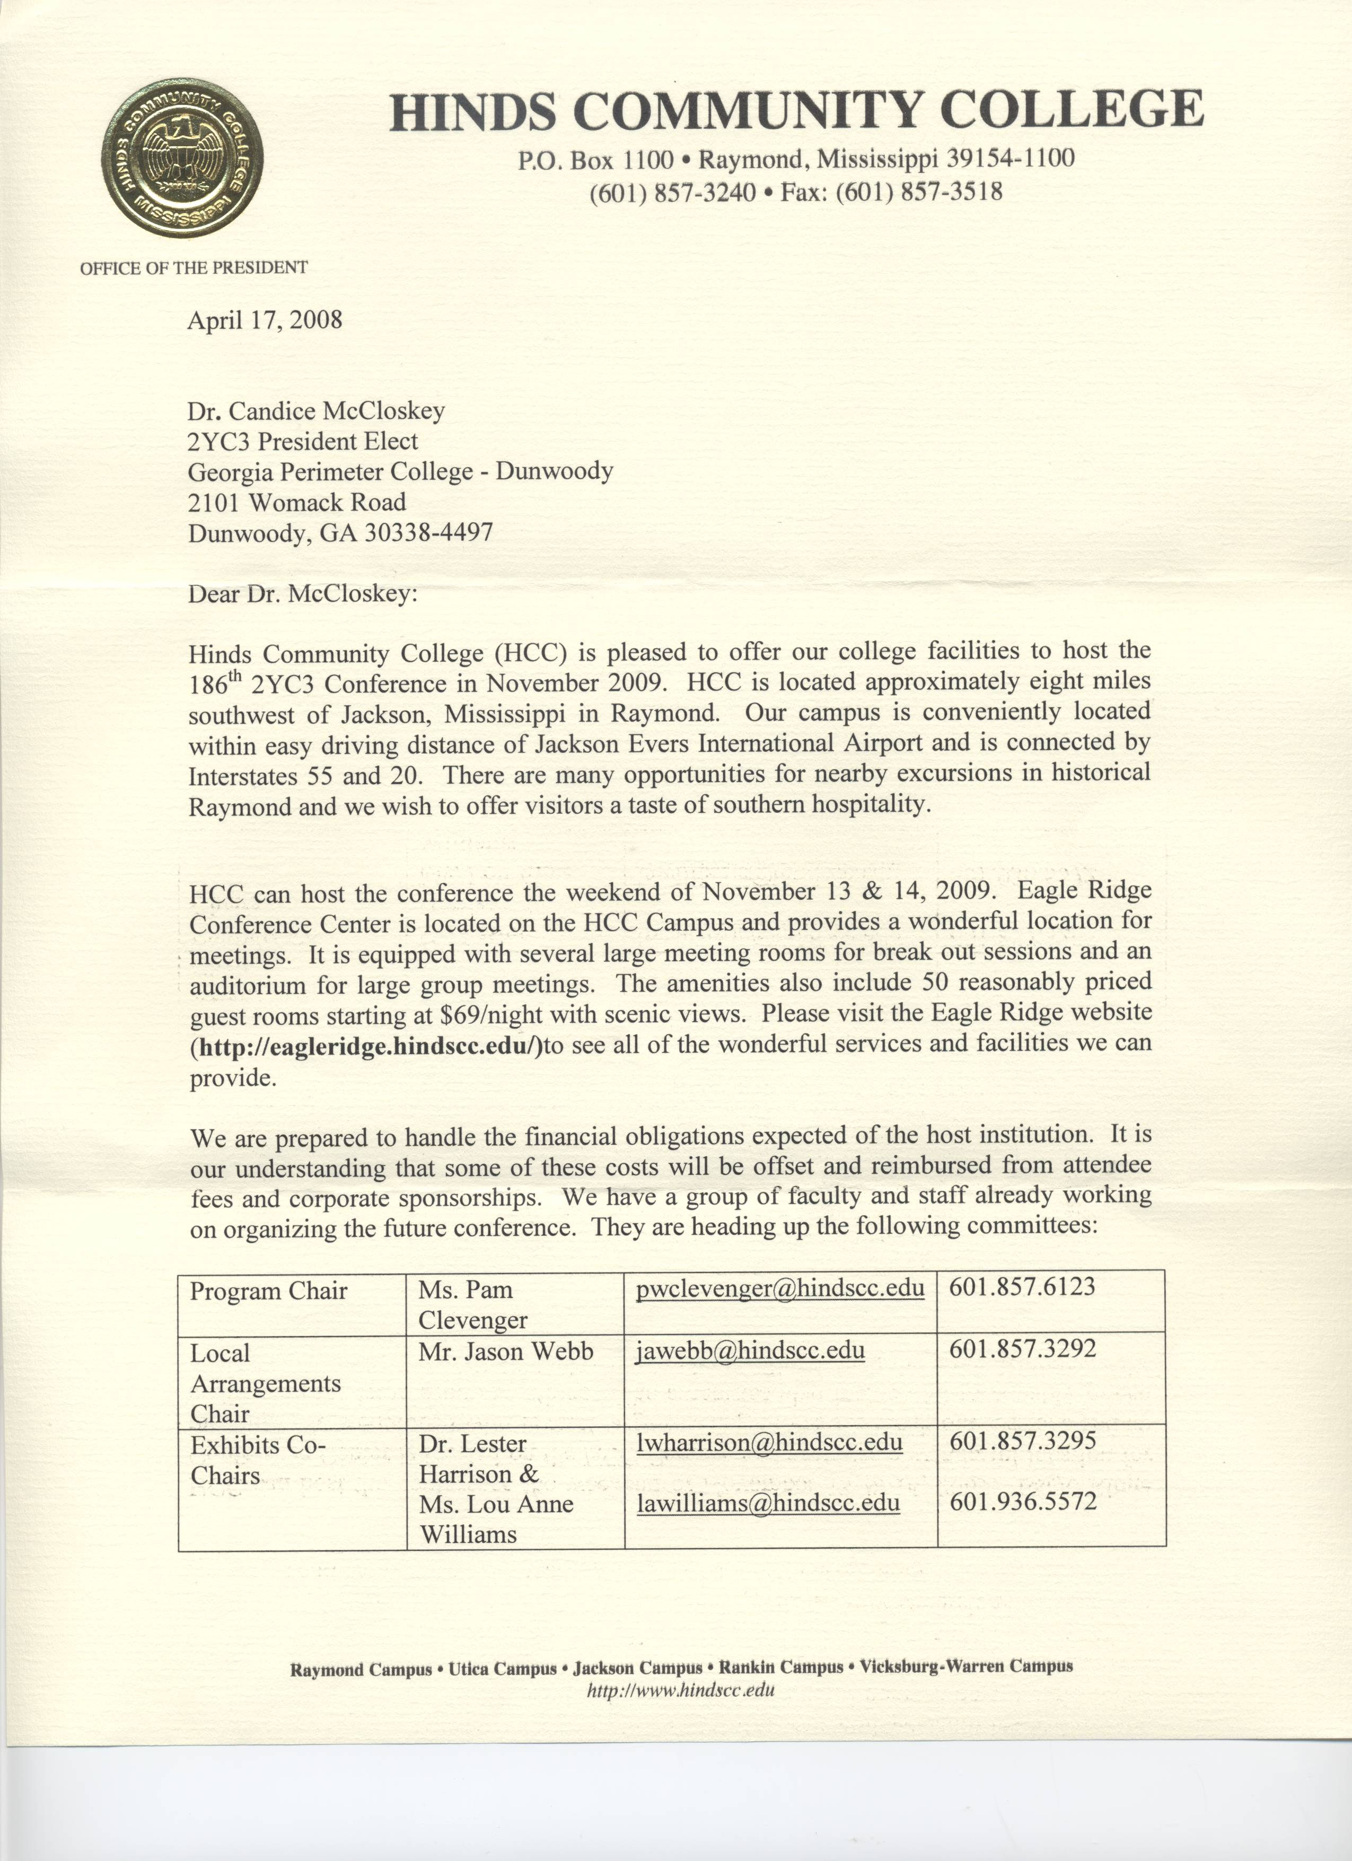

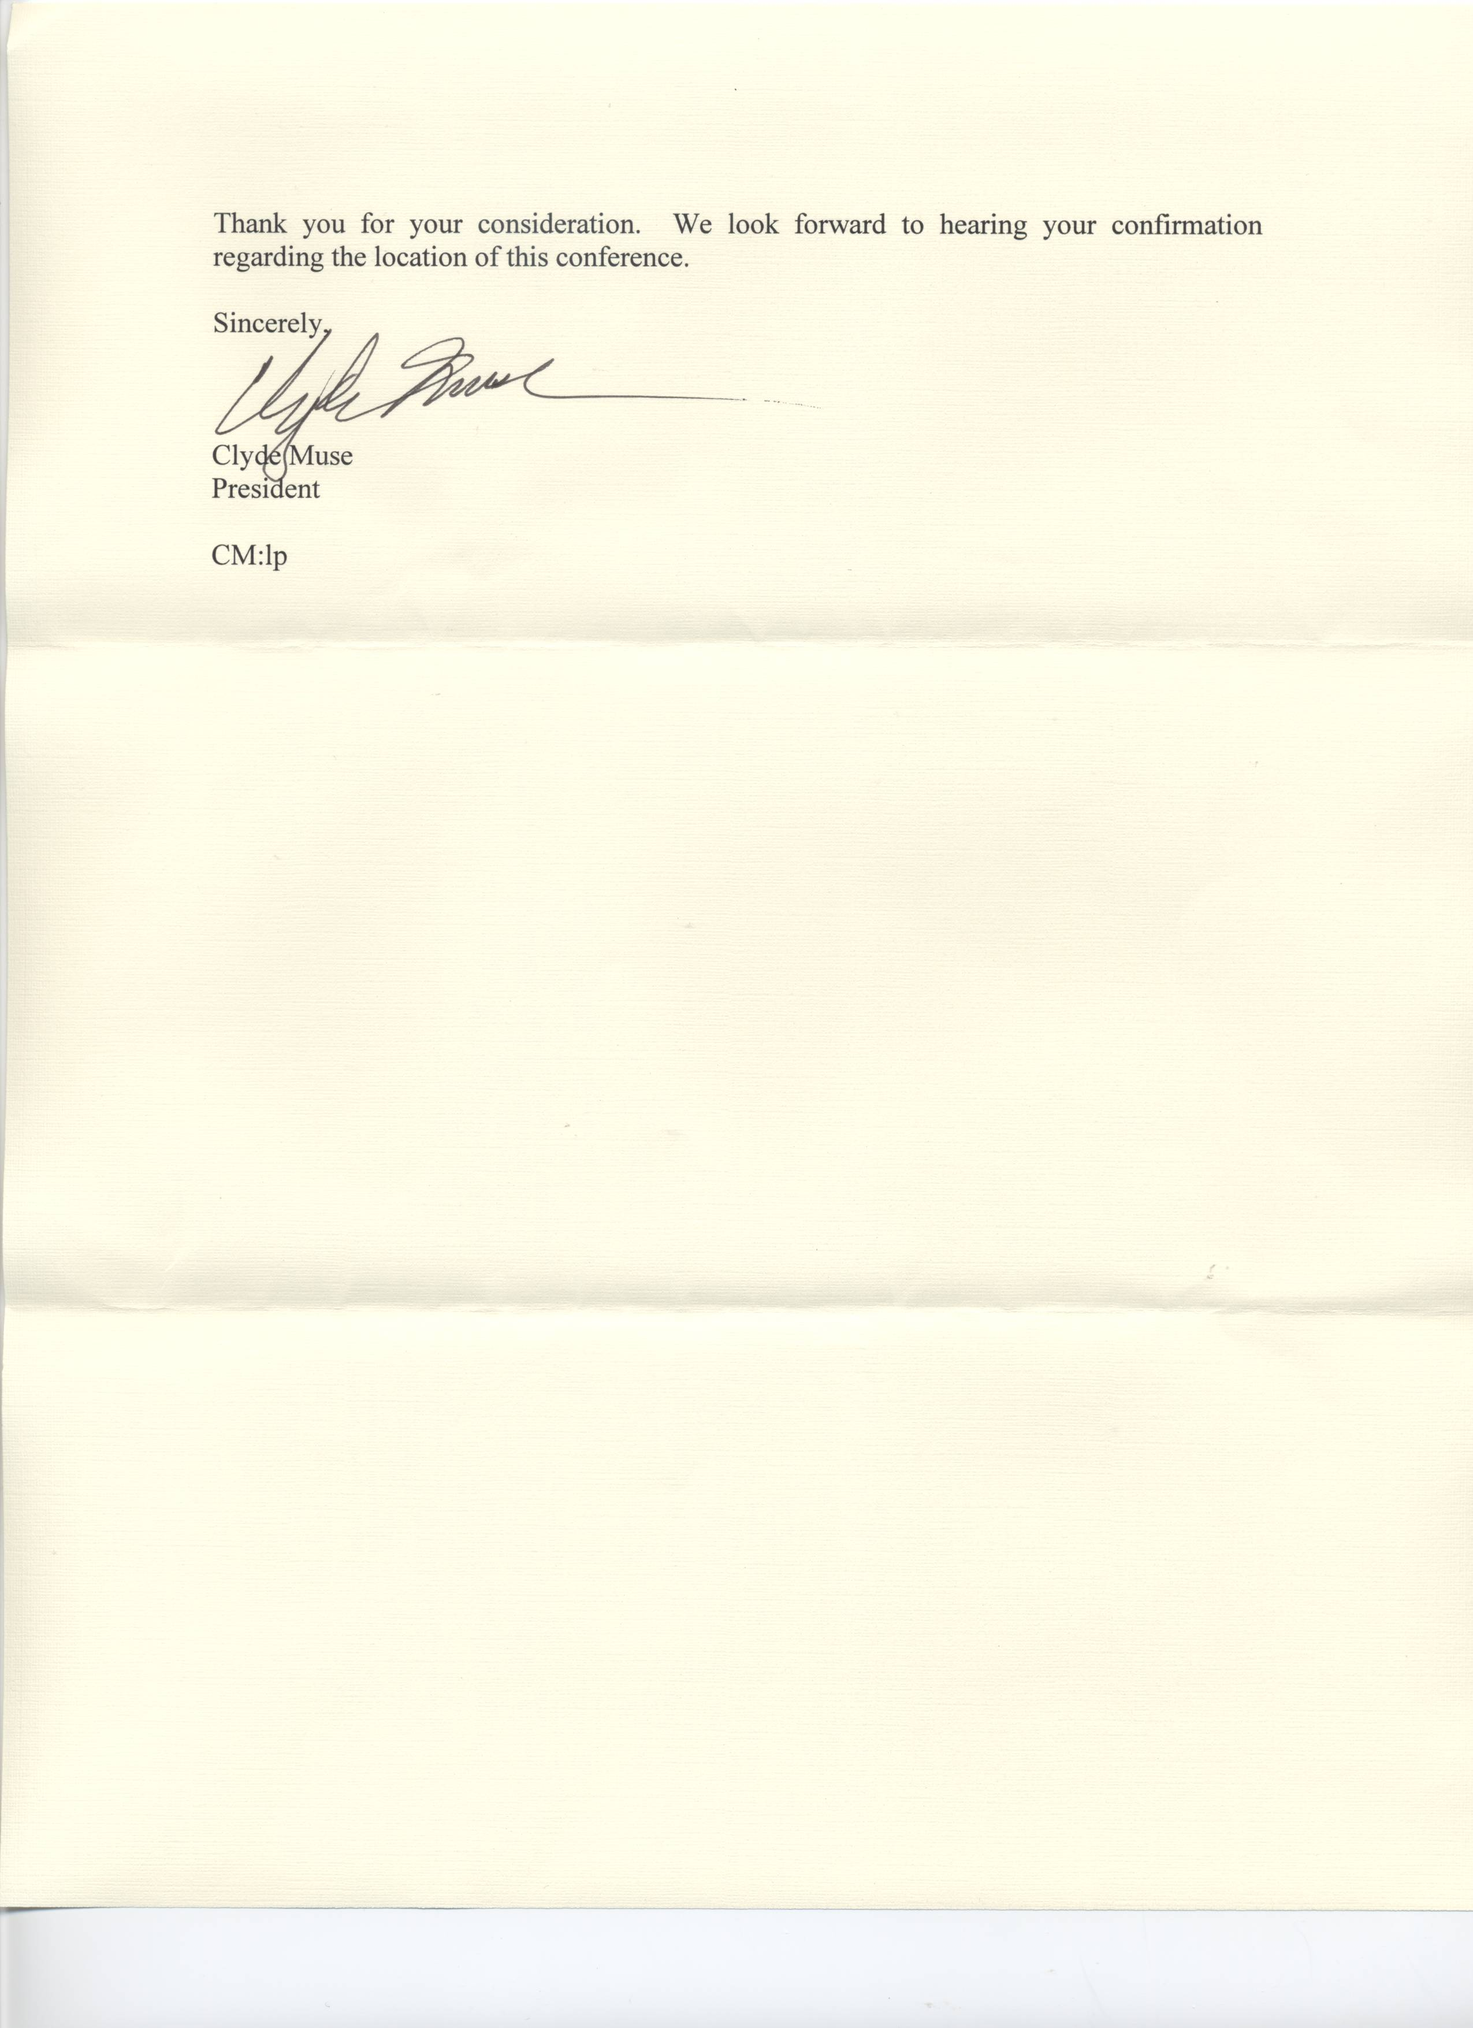

Double click below to open the excel workbook.



**Email Template for Presenters**

Dear **Name**:

Thank you for agreeing to participate in the **XXX** Two-Year College Chemistry Consortium Conference on **Date**. Your presentation will take place on **Friday or Saturday** **morning/afternoon** at **time** in room **XXX**. You have 35 minutes for your presentation. The time limit will be strictly enforced to ensure that program stays on schedule. All rooms are equipped with a PC with Microsoft Office, internet access, projector, VCR and DVD players, and a blackboard. The rooms also have quick connections for lap top computers.

Title of Presentation: **XXX**

Abstract: **Not on file, please send as soon as possible**

Please respond to confirm that all information is correct and the presentation time works for your schedule. Do not hesitate to contact me if you have any questions or visit the conference website at:

Thank you!

**209th 2YC3 Conference**

**Chemical Education Resources**

**Front Range Community College**

**3645 West 112th Avenue**

**Westminster, CO**

**March 20-21, 2015**

**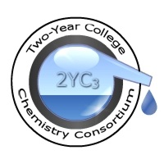**

**Conference Organizers**

**Dennis Kissounko**

*Arapahoe Community College*

**Jason Jadin**

*Rochester Community and Technical College*

**Mary Mattson**

*Front Range Community College*

**Table of Contents**

Conference Sponsors page 2

Conference Schedule page 3

Conference Exhibitors page 8

Abstracts page 9

Campus Maps page 19

Directions to Denver Marriott-Westminster page 21

Future 2YC3 Conferences page 22

2YC3 Officers page 23

Notes page 24

**Conference Sponsors**

We would like to thank the following for their monetary donations. Please thank them personally when visiting their tables.

When exhibitors register they have the opportunity to donate sponsorship money. This is space where they can advertise their logos. In this example, all sponsors were given the same advertising space regardless of the $ donation (2 gave $100, 2 gave $50).

You could also break the sponsors into categories and have them submit ads. $50 is the bronze level which gets the company a ¼ page ad in the program. $100 is the silver level which gets a ½ page ad in the program. $200 is the gold level which gets a full page ad. How you do the donations/sponsorship is up to you.

****





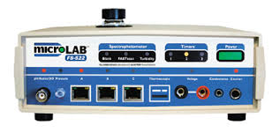

****

**Friday, March 20**

**8:00-8:45 Registration, Refreshments, Exhibits**

One large room/space (~2000 sq ft) is preferred. Two rooms next to each other is OK.

**8:45-9:00 Welcome**

*Administrator from College*

Large classroom/auditorium (~75 minimum capacity)

**9:00-10:00 Keynote Address I**

Title

*Name, Institution*

Large classroom/auditorium (~75 minimum capacity)

**10:00-10:30 2YC3 Membership Meeting**

*Name, 2YC3 Chair*

Large classroom/auditorium (~75 minimum capacity)

**10:30-11:00 Refreshment Break and Exhibits**

One large room/space (~2000 sq ft) is preferred. Two rooms next to each other is OK.

note how session A has similar presentations (writing journals and discussions) and session B deals with technology in PP I and II.

**11:00-11:35 Parallel Presentation Session I**

1. Reflective Journals in Chemistry Classes

*Olga Katkova, Truckee Meadows Community College*

Small classroom (~30 minimum capacity)

1. Use of Go Wireless and Node Probes along with iPads in Chemistry and Integrated Science Laboratory Classes

*Bernard Majdi, South Georgia State College*

Small classroom (~30 minimum capacity)

**11:40-12:15 Parallel Presentation Session II**

1. Clustered Online Discussion Board: An Online Tool to Enhance Student Learning and Participation

*Jomy Samuel, DeVry University*

Small classroom (~30 minimum capacity)

1. 21st Century Innovation in Chemistry: A Comprehensive Software Program Interactively Covering a Full Year of General Chemistry

*Ketan M. Trivedi, Virginia Tech*

Small classroom (~30 minimum capacity)

**12:15 - 1:20 Lunch Break and Exhibits**

we typically have two groups (A and B) running during parallel presentation sessions. If you get a good response from the call for papers, then for some sessions run three groups (A, B, and C).

One large room/space (~2000 sq ft) is preferred.

**1:20-1:55 Parallel Presentation Session III**

1. Hybrid Labs Make Everyone Happy

*Dan Black, Snow College*

Small classroom (~30 minimum capacity)

1. Organic Chemistry and the Native Plants of the Sonoran Desert: A New Model for the Undergraduate Laboratory

For the afternoon sessions note that session A deals with hybrid courses. Try to place related presentations in a specific session group.

*Timothy Minger, Mesa Community College*

Small classroom (~30 minimum capacity)

1. Chemistry Is Everywhere But Where Do I Find It?

*Scott Donnelly, Arizona Western College*

Small classroom (~30 minimum capacity)

**2:00-2:35 Parallel Presentation Session IV**

1. Technology and Tools for the Hybrid Chemistry Class (or Any Chemistry Class)

*Jonathan Gittins, Delta College*

Small classroom (~30 minimum capacity)

1. Cellphones in the College Chemistry Classroom: Pariah or Messiah?

*James MacArthur, Western Nebraska Community College*

Small classroom (~30 minimum capacity)

1. Instrumentation in an Online Introduction to Chemistry Laboratory Course

*Shayna Burchett, State Fair Community College*

*Jack Lee Hayes, State Fair Community College*

Small classroom (~30 minimum capacity)

**2:40-3:15 Parallel Presentation Session V**

1. Introducing a Blended Laboratory Component in a General Chemistry Course

*Shayna Burchett, State Fair Community College*

*Jack Lee Hayes, State Fair Community College*

Small classroom (~30 minimum capacity)

1. Connecting Old Knowledge and New Knowledge: Techniques to Help Students Recall Prior Knowledge More Readily and Effectively in Chemistry Courses

*Shadi Assaf, Olive-Harvey College*

Small classroom (~30 minimum capacity)

1. Using Computers to Visualize Data, Cut Lab Costs, and Involve Students in Active Learning

*John Amend, Montana State University*

Small classroom (~30 minimum capacity)

**3:15-3:45 Refreshment Break and Exhibits**

One large room/space (~2000 sq ft) is preferred.

**3:45-4:45 Keynote Address II**

Chemical Education Resources to Engage Chemistry Students in Smart Energy and a Sustainable Future

*Wayne Jones, SUNY-Binghamton*

Large classroom/auditorium (~75 minimum capacity)

**5:00-5:45 Tour of Facilities, Local Industry, Local Attraction (Optional)**

An example: The conference in Rochester, MN had a keynote speaker from the Mayo Clinic Medical Laboratory Science Department talk about the chemistry of this growing field and how instructors can incorporate laboratory science principles into general and organic chem.

After the talk, we then offered a free tour of the medical science laboratory at the “world famous” Mayo Clinic. Attendees were able to see the instrumentation used in the lab and walk around the numerous buildings making-up the 10 sq block downtown campus.

**6:00-7:00 Social Hour**

Conference Hotel, Local Pub/Restaurant/Attraction

The tours, local attractions, and social hour can also be combined into one large time block. This is also the time for holding a banquet if you chose to go that route.

Another option is to run more parallel sessions at this time and not have another keynote. If having a banquet, you could also move the keynote speaker to after the dinner. There is flexibility with the afternoon events.

Another example: The conference in Appleton, WI had a tour of a microbrewery and the social hour was also held at the brewery.

The conference in Canton, OH had the social hour at the NFL hall of fame, where tours were offered.

In Jacksonville and Dallas, groups toured the science museum.

**Saturday, March 21, 2015**

**8:00-8:45 Registration, Refreshments, Exhibits**

One large room/space (~2000 sq ft) is preferred.

**8:45-9:45 Keynote Address III**

Undergraduate Research - A Tool to Explore Chemistry and Excite Newcomers

*Debbie Crans, Colorado State University*

All of the publisher presentations are in session B.

A word of caution: presentations from publishers are welcomed but emphasize that the goal is not to sell their product at the talk or use this as free advertisement. That is the purpose of the exhibit room.

Bring authors in as experts in their field. For example, Jason Overby is an author of an atom’s first book. He doesn’t talk about his book, but rather talks about the atom’s first movement. What is the approach, why it make sense?

Have homework system representatives use the time as an open forum. Better yet, have them bring in a 2-year faculty member to discuss how the system has helped their students.

Large classroom/auditorium (~75 minimum capacity)

**9:50-10:25 Parallel Presentation Session VI**

1. Optimizing Our Time with Students in the Classroom

*John Suchocki, Saint Michael's College*

Small classroom (~30 minimum capacity)

1. Guidance for When You Can't Be There

*Christine Pruis, W.W. Norton & Company*

Small classroom (~30 minimum capacity)

**10:30-11:00 Refreshment Break and Exhibits**

One large room/space (~2000 sq ft) is preferred.

**11:00-11:35 Parallel Presentation Session VII**

1. Is Teaching Science Online with Remote Labs Cost Effective?

*Dan Branan, Colorado Community College System*

Small classroom (~30 minimum capacity)

1. Learning Needs of Students When Writing a Textbook

*Karen Timberlake, Los Angeles Valley College*

Small classroom (~30 minimum capacity)

**11:40 - 12:15 Parallel Presentation Session VIII**

1. Undergraduate Chemistry Research: A Resource for Students to Better Understand Chemical Concepts

*Jose Conceicao, Metropolitan Community College*

Small classroom (~30 minimum capacity)

1. Atom's First: What's Old is New

*Jason Overby, College of Charleston*

Small classroom (~30 minimum capacity)

**12:15-1:20 Lunch Break and Exhibits**

One large room/space (~2000 sq ft) is preferred.

**1:20-2:30 Workshop Session I**

1. Get a Jump Start Using the ACS Assessment Tool for Chemistry in Two-Year College Programs

*Olga Katkova, Truckee Meadows Community College*

*Heather Sklenicka, Rochester Community and Technical College*

Small classroom (~30 minimum capacity)

1. Hands-On Workshop on NMR and IR Spectroscopy: Experience for Yourself Two of the Most Important Analytical Tools in Teaching Laboratories

*Katherine Paulsen, Thermo Fisher Scientific*

*Brian Bertsch, Thermo Fisher Scientific*

Small classroom (~30 minimum capacity)

**2:35-3:10 Parallel Presentation Session IX**

1. Just Say 'NO' to Virtual Labs: Hands on Lab Activities for the Online Chemistry Student

*Lance Lund, Anoka Ramsey Community College*

Small classroom (~30 minimum capacity)

1. Anyone Can Do It... The Democratization of the Distribution of Educational Tools

*Mark Bishop, Chiral Publishing Company*

Small classroom (~30 minimum capacity)

**3:15-3:50** **Parallel Presentation Session X**

1. Catchy Phrases: Elegance or Junque?

*Alan Weir, Fox Valley Technical College*

*Benjamin Weir, University of Wisconsin - Stout*

Small classroom (~30 minimum capacity)

1. Panel Discussion: Chemistry Textbooks of the Future

*Mark Bishop, Erik Fahlgren, Terry Haugen, Ketan Trivedi*

Small classroom (~30 minimum capacity)

The total number of presentation sessions will vary depending the number of submitted papers.

Some conference have a 10-15 minute closing, but that is optional.

**Conference Exhibitors**

include a page in the program which lists all of the venders at the conference.

We would like to thank the following for exhibiting at the 209th 2YC3 conference. We encourage all attendees to visit their tables during the conference.

|  |  |
| --- | --- |
| ACS Undergraduate Office | Image result for anasazi instruments logo  Anasazi Instruments |
| eScience Labs, LLC | McGraw Hill Higher Education |
| Image result for microlab info  MicroLAB | Morton Publishing |
| Pearson Education | Roberts and Company Publishers |
| Thermo Fisher Scientific | WebAssign |
| W.W. Norton & Company | |

**Abstracts**

**Keynote Address I**

Dynamic Visualizations and Student Conceptual Understanding of Chemistry Topics

*Jerry P. Suits*

*University of Northern Colorado, Greeley, CO*

Animations and simulations are dynamic visualizations as opposed to static visualizations (e.g. diagrams, etc.). The goal of this talk is to show how students use dynamic visualizations to internalize concepts and imagery and to explore chemical phenomena. The speaker will describe several recent advances in visualization technologies that can facilitate this process. Also, a variety of findings from research studies in chemical education show how good design features in these visualizations can help students understand chemistry topics. Their understanding can be manifested as ‘mental models’ when students draw and explain their conceptions of chemical phenomena. This talk is useful for anyone who needs to recognize how students learn from good multimedia software in chemistry.

**Presentation I-A**

Reflective Journals in Chemistry Classes

*Olga Katkova*

*Truckee Meadows Community College, Reno, NV*

Are you interested in unlocking the secrets of student participation in your classes? I have been using reflective journals in chemistry classes for two last years and I could see that it made a huge difference on the level of the critical thinking of my students.  The use of reflective journals is based on the concept that good learners tend to be reflective thinkers. The major goal is to provoke the students to think about what they are learning in the class. I would like my students to analyze the material that we cover for every chapter and be able to reflect on it. Plus, many of my colleagues found reflective journals as a great addition to their classes.

**Presentation I-B**

Organic Chemistry and the Native Plants of the Sonoran Desert: A New Model for the Undergraduate Laboratory

*Timothy Minger*

*Mesa Community College, Mesa, AZ*

The Physical Science Department at Mesa Community College (Mesa, Arizona) is developing a novel organic chemistry laboratory curriculum that uses the naturally occurring chemicals found in local native plants such as jojoba and chia as a starting point for laboratory activities using guided inquiry. MCC chemistry faculty Timothy Minger, Valentina Nedelkova and John Zikopoulos have been designing and implementing laboratory activities for undergraduate students to extract, purify, and study organic molecules from desert plants. The project is funded in part by a grant from the National Science Foundation awarded in 2012 (“Organic Chemistry and Native Plants of the Sonoran Desert: A New Model for the Undergraduate Laboratory”, NSF grant 1140887). Project progress is being evaluated by M. Jean Young & Associates of Tucson using formative and summative assessments. Project objectives include isolating and identifying materials from native plants; providing hands-on training for students in key organic laboratory instrumentation for analysis and purification of plant materials; introducing students to variety of applications of the compounds found in plants, e.g., medicinal, agricultural and other contexts; and encouraging student participation in independent study outside the lab classes. Many of these native plants hold a traditional place of importance in Hispanic and Native American cultures and have medicinal and other applications. MCC students and others are getting hands-on experience with applying actual research methods to contemporary and relevant scientific topics. Over the last three years, students taking organic chemistry lab courses at MCC have worked with a variety of plants. For example, our students have extracted oil from the seeds of the jojoba plant and converted it to biodiesel using a transesterification reaction. They have also extracted and analyzed the oil from chia seeds, learning about antioxidants, fatty acids, and triglycerides in the process.

**Presentation II-A**

Anyone Can Do It…the Democratization of the Distribution of Educational Tools

*Mark Bishop*

*Chiral Publishing Company, Monterey, CA*

Because of the development of easy-to-use computer tools (InDesign, Illustrator, Photoshop, Dreamweaver, Flash, Camtasia, etc.), easy access to the Internet for most students, and growing acceptance of electronic educational tools, including textbooks, it has become possible for individuals to develop and distribute educational materials without the aid of the large academic publishers. In my talk, I’ll describe the evolution of my project, which includes two versions of my textbook (*An Introduction to Chemistry)* in several formats, including regular printed books and various forms on the Net: PDF, EPUB (for iPhones, iPads, and Android devices), MOBI for Kindle, and Flash-based PowerPoint-like presentations with me reading the text. I’ll also briefly describe my book’s many supporting tools, including animations, tutorials, online lectures, and more. All of these tools except the printed books are freely available with no user names or passwords at preparatorychemistry.com. The main goal of my talk will be to explain how you can do some or all of the things I’ve done. I’ll describe the tools you’ll need, where you can get them at the lowest cost, and some idea of the time it will take to create your own materials.

**Presentation II-B**

A 21st Century innovation in Chemistry: A comprehensive software program, interactively covering a full year of ‘General Chemistry’

*Ketan Trivedi*

*Virginia Tech, Blacksburg, VA*

The College Boards, has approved for the first time ever, an interactive software program for teaching college level, General Chemistry. Twenty one chapters of interactive tutorial instruction provides an engaging system, requiring student interaction. An audio/text, flash drive mounted system that students prefer over a textbook. Includes; printable notes, Glossary, Tables, Calculator and Periodic Table, and a searchable Index. No internet connection required and students can study at their own pace. Each chapter has multiple problem sets, using various pedagogies, some with drop down solutions (audio/text), or some providing interactive solutions. Student interaction includes ‘drop and drag’ structures, student drawn graphs. Also included are hundreds of graphic representations and lecture/demo videos. Instant feedback to the student on thousands of embedded questions within the tutorials. No question encountered is left unanswered. Much more engaging for the student, and certainly less expensive than the textbooks!

**Presentation III-A**

Hybrid Labs Make Everyone Happy

*Dan Black*

*Snow College, Ephraim, UT*

One question that the explosion of online courses has created is in regard to maintaining quality laboratory experiences for students.  These questions tend to focus on how to provide a “real” lab experience and yet maintain the flexibility that distance education affords.  This presentation explores a hybrid model using at-home kits combined with limited on-site lab experiences to ensure rigor and maintain quality in lab instruction at a distance. Students perform a number of experiments at home using a pre-packaged lab kit and then come to campus a few times during the semester to do other labs.  In this exploration, students visited campus three times and performed two labs each time.  This allowed them to use more significant equipment and do experiments that have larger safety concerns.  Typically in this model students perform a total of sixteen labs in comparison to twelve that on campus students work through.  This extra work tends to offset the rigor questions.  Students are also able to schedule three days for on campus visits with little problem if they have notice of the dates.  There also seems to be an increase in success in the course when they actually meet the instructor on lab days. Come hear about lessons learned and outcomes achieved in his hybrid course pairing lab kits with limited campus visits.

**Presentation III-B**

Technology and Tools for the Hybrid Chemistry Class (Or Any Chemistry Class)

*Jon Gittins*

*Delta College, University Center, MI*

While technology does not make a good teacher, having useful technological tools can help. As I started preparing to teach a hybrid chemistry course (lecture at home, labs on campus), I questioned how I was going to be able to effectively place the lecture portion online. There are two tools that I have found extremely useful in preparing the online portion of a hybrid course, and I plan to share how I use both of these tools. The first, Softchalk, is an interactive webpage creator. Instead of static text, Softchalk allows me to create different types of quiz questions and activities that are embedded in the text, keeping students engaged. Videos can also be embedded in these webpages. I will also demonstrate how these webpages interact with the college’s online learning management system. The second tool, Microsoft Office Mix, is a tool that I have mainly used to create videos for Softchalk. It is an add-on in PowerPoint that allows the creator to easily add writing and speech to any slide. Office Mix can also be used to create quiz questions (similar to those in Softchalk, though with more limited options), and these videos and quizzes can then be uploaded to Microsoft’s “cloud.” Students can then view these videos and quizzes from many different approved devices, with the results being recorded. Students have had positive responses to both of these tools, and I have extended use of both to my traditional, non-hybrid Introductory and General Chemistry 1 courses.

**Presentation III-C**

Introducing a Blended Laboratory Component in a General Chemistry Course

*Shayna Burchett, Jack Lee Hayes*

*State Fair Community College, Sedalia, MO*

Missouri University of Science and Technology undergraduate lab space has reached its capacity. Freshmen lab sections run 5 days a week and still have a sizable wait list of students who are required to take the course for their degree. To address this pressure, the campus has modified and implemented a design originated at State Fair Community College of blended wet labs. If successful, the project will allow for larger student throughput while maintaining the rigor of a non-virtual lab experience. Labs were identified that would allow learners to take a small kit of reagents and complete the activities outside of the scheduled lab time and space. Topics of this discussion include curriculum design to meet ACS guidelines and Missouri University of Science and Technology EHS concerns, data collected to date, and assessments tools to measure efficacy of project.

**Workshop I-A**

Hands-On Workshop on NMR and IR Spectroscopy: Experience for Yourself Two of the Most Important Analytical Tools in Teaching Laboratories

*Katherine Paulsen*

*Thermo Fisher Scientific, Madison, WI*

NMR and IR spectroscopy are complementary techniques for structure characterization, and arguably the most important analytical tools in the modern organic chemistry laboratory. We present an overview of the importance of providing students hands-on experience with NMR and IR spectroscopy. We will also introduce several example activities that can be conducted with this type of instrumentation within the general and organic chemistry curriculum. You will have the opportunity to run samples on our compact, affordable NMR and IR spectrometers.

**Workshop I-B**

Conceptual Academy as a Tool for Student-Centered Learning

*John Suchocki*

*Saint Michael’s College, Colchester, Vermont*

Conceptual Academy is an online platform designed to optimize the delivery of academic content so that the student can come to class prepared for the more difficult task of actually learning that content, which is supported by working with classmates under the expert guidance of the course instructor. By adopting this approach as embodied by Conceptual Academy, the instructor has more time and energy to spend in developing student-centered classroom activities. This may include a greater emphasis on team-based learning, POGIL, Learning Catalytics, or any technique or technology that supports interactions among students and hands-on experiences right within the classroom. Conceptual Academy is being created by the authors of the “conceptual” line of science textbooks and now features about 500 of their video tutorials each collated to the chapter sections of their textbooks. Notably, its prime audience includes non-science majors taking a required course in a physical science. However, this platform also has application for students needing support in the basic concepts for their higher-level general chemistry or college physics courses. Through this workshop, the development of Conceptual Academy, its philosophy, and its various resources will be presented. Participants will be shown how to create an account and how to make use of the various tools.

**Presentation IV-A**

Writing a GOB Textbook to Meet Learning Needs of Students

*Karen Timberlake*

*Los Angeles Valley College, Van Nuys, CA*

As GOB chemistry instructors, we are aware of the challenges students face in the course and seek ways to develop and deliver strategies that provide success for students. As an author of GOB chemistry textbooks, my challenge has been to address those same student challenges and develop strategies for success in the written format. This presentation shows the incorporation of course content for underprepared students into a textbook. Strategies include reviewing basic math for chemistry early in the semester, highlighting key math and core chemistry skills, providing guides to problem solving, analyzing problems, and solving word problems. The writing style uses words and reading level appropriate for students underprepared in language and learning skills. Real-life clinical stories throughout the chapters with clinical applications in questions and problems provide motivation and demonstrate the relevance and need for an understanding of chemistry in medical and health careers. Many health professions programs require one or two semesters of chemistry as a General, Organic, and Biochemistry (GOB) course. This course has a unique set of challenges for the chemical educator including time management, content expectations by programs, and unprepared students who may not see how chemistry applies to their major. Educators are invited to present on their development/management of course content, assessment of student learning, or evidence-based classroom instructional strategies. This session will conclude with a discussion where the audience and the presenters will identify successful trends in teaching the GOB course.

**Presentation IV-B**

Atoms First: What’s Old is New

*Jason S. Overby*

*College of Charleston, Charleston, SC*

For the past 40 years, general chemistry has been taught from the perspective of a stoichiometry-first course with an emphasis on giving students tools to go into the laboratory setting and conduct experiments. However, to counter this approach, an atoms first-centered course has rapidly been gaining in popularity as an attempt to bring a coherent and logical sequence to teaching the topics of general chemistry. This talk will explore the atoms first approach in general chemistry and provide some insight into its curricular focuses as well as delve into the problem of the laboratory component of the course.

**Presentation IV-C**

Using Computers to Visualize Data, Cut Lab Costs, and Involve Students in Active Learning: A New Look at Spectrophotometry

*John Amend*

*Montana State University (Emeritus), Bozeman, MT*

Computers can do a lot more for our lab students than just quickly collect data using small, inexpensive, and safe samples.  Both POGIL and the Science Writing Heuristic advocate an inquiry process that starts with a question about a real chemical system.  Students and their instructor turn these questions into an experiment, conduct the experiment, and work together to use their observations to develop a model of the system that explains the behavior they observed.   With additional runs through this plan -> work -> evaluate cycle, they improve their model and understanding of the chemical concept. They understand the experiment and the concept when they leave the lab.

We will, involving members of the audience, do several live experiments from general chemistry lab that demonstrate this process – experiments in thermochemistry, the behavior of gases, acid-base chemistry, and a new look at visualization and projects in spectrophotometry.

**Presentation V-A**

Chemistry Is Everywhere but Where Do I Find It

*Scott Donnelly*

*Arizona Western College, Yuma, AZ*

Chemical educators have an uphill climb convincing college undergraduates that chemistry is pivotal to understanding the physical world and its phenomena. To meet this daunting challenge chemical educators have created and organized an impressive library of high-end digital resources to choose from. But there is a much larger library waiting to be explored and utilized. It includes non-chemistry websites and databases, and print media. In this presentation the presenter will talk about these ‘non-chemistry’ resources from which to draw ideas that can be used to augment one’s lecture or labs. The presenter also will weave into the narrative how these resources can be used to show the complementary relationship between theory as discussed in lecture/class and application of theory as found in the ‘real’ world.

**Presentation V-B**

Use of Go Wireless and Node Probes Along with iPads in Chemistry and Integrated Science Laboratory Classes

*Bernard Majdi*

*South Georgia State College, Waycross, Georgia*

Go wireless temp probe and Go Wireless pH probe, developed by Vernier Software and Technology were used along with iPads minis and Go Wireless app and Graphical Analysis app to do experiments in chemistry and integrated science laboratory classes. These experiments included thermochemistry of Alka-Seltzer dissolved in water and comparison of anti-acids titrated with hydrochloric acid. Node sensor platform including Node Therma and Node CO2 also work with Graphical Analysis app to do wireless measurements. These experiments included rate of carbon dioxide production during respiration. Instructor and student experiences will be discussed.

**Presentation V-C**

Instrumentation in an online Introduction to Chemistry laboratory course

*Shayna Burchett, Jack Lee Hayes*

*State Fair Community College, Sedalia, MO*

State Fair Community College has offered a completely online Introduction to Chemistry course since Fall of 2010. Throughout the maturation process of the course, a variety of instrumentation has been utilized to meet the instrumentation needs of the students. This session will focus options that have been explored and the lessons learned from the experiences.

**Keynote Address II**

Chemical Education Resources to Engage Chemistry Students in Smart Energy and a Sustainable Future

*Wayne Jones*

*SUNY Binghamton, Binghamton, NY*

Smart Energy is a broad, often overused, term in society today which could have significant impact on our future.  This talk will explore smart energy in the context of energy generation, energy storage, and energy efficiency in our modern technology environment.  Examples of next generation technologies where chemistry will play a key role will be discussed.  Further, available on-line and hands on activities will be discussed that are suitable to engage chemistry students in dialogue around this important topic in your classroom and curriculum.

**Keynote Address III**

Chemistry Research as an Undergraduate Student is Fun – Examples from CSU Students

*Debbie C. Crans*

*Colorado State University, Fort Collins, CO*

Undergraduate research can be on many different problems and teach students a range of different problem solving skills. Research in the Crans group at Colorado State University is multidisciplinary because Debbie Crans’ research interests are in metals in medicine, coordination chemistry, and spectroscopy and drug formulation. Different research problems that undergraduate students have done in the past reflect these interests. Examples of projects taken on by undergraduate researchers in organic and inorganic chemistry are: one student was determining the location of cholesterol in model membrane systems and vanadium dipiciolinate complex uptake. Another student studied a redox reaction in a Nano sized reactor and showed by simply confining the compound and preventing it access to the reductant the reaction stopped. Other students prepared a series of compounds and their inorganic chemistry was characterized. One student prepared a gel-like material containing an anticancer agent that was administered to mice having just had a breast cancer tumor removed. An example of projects taken on by students in analytical and physical chemistry are as follows: One student discovered proton gradients in Nano sized water droplets. Another student measured the affect of CO2 on nano sized water droplets by measuring changes in pH when there are not enough water molecules in the droplet to determine the pH. Another student prepared and characterized alkali ion surfactants (such as sodium bis(2-ethylhexyl)sulfosuccinate) and in the process develop a method to measure the water content in the surfactants by 1H NMR spectroscopy. Another student learned to synthesize vanadium(V) catechol complexes, and in the characterization of these materials learned that the 51V NMR solid-state chemical shifts are directly proportional to the electronic properties of the vanadium atom. All together, the contributions of one student may seem small, the list above show that the collective contributions are amazing and documents that even young students can contribute in a very meaningful manner in a research program.

**Presentation VI-A**

Guidance for When You Can’t Be There

*Christine Pruis*

*Chemistry Subject Matter Expert, W. W. Norton*

Created by chemistry educators, SmartWork is the most intuitive online tutorial and homework system available for general and organic chemistry. In minutes, an instructor can create an assignment that is automatically graded, giving students answer-specific feedback, effective hints, tutorials and links to an interactive Ebook.

* *Every* problem in SmartWork has both general hints and answer-specific feedback so students receive the help they need when they need it, while the integrated Ebook provides a learning system that promotes practice and reading.
* SmartWork’s detailed gradebook features, including the ability to view each student’s incorrect attempts, allow personalized office hour interactions.
* The drawing, arrow pushing, and equation editor tools were developed to significantly reduce formatting errors and, as a result, reduce the student frustrations that can come with using an online homework system.
* All questions are tagged with specific learning objectives, Bloom’s taxonomy levels, and difficulty scores to better correspond with course objectives.
* Instructors have the power to *easily* modify system-provided problems and feedback or author their own.

This talk will overview the system, question types, and specific feedback with an emphasis on how instructors can customize material. Highlights will include an overview of designing chemical equation entry, structure drawing, and arrow-pushing questions all with the specific feedback that you would give to your students!

**Presentation VI-B**

Optimizing Our Time with Students in the Classroom

*John Suchocki*

*Saint Michael’s College, Colchester, Vermont*

How do we spend our time with students within the classroom? Are we mostly delivering content or mostly facilitating the learning of that content? Where might be the best balance of the two? For this presentation, the author will moderate a discussion on the challenges we face in asking students to come to class prepared for active learning. We’ll discuss techniques useful for keeping students engaged. We’ll look at how recent technologies can be used to support an approach where students read material and attend our lectures outside of the classroom and then come to class prepared to study under our expert guidance.

**Presentation VII-A**

Panel Discussion: Chemistry Textbook of the Future

*Panelists: Mark Bishop,a* Erik Fahlgren,*b* Terry Haugen,*c Ketan Trivedi d*

*Mediated by Denis A. Kissounko e*

*a Chiral Publishing Company*

*b W. W. Norton & Company*

*c Pearson Chemistry Publishing Company*

*d Virginia Tech, Blacksburg, VA*

*e Arapahoe Community College, Littleton, CO*

Currently we have plenty of good chemistry textbooks published that are available for students. However, how will the “ideal” chemistry textbook will look like 5-10 years from now? What does the new generation of students expect to see in a textbook? How can we incorporate cutting edge technologies and social media into new generation chemistry textbooks? Will the new generation textbooks be fully digital or should we keep hardcopy format as well? What new chemistry concepts will appear in the chemistry textbook of the future? How affordable the new generation textbooks will be? The board of panelist representing publishing companies and college faculty will provide insights into these questions.

**Presentation VII-B**

Connecting Old Knowledge and New Knowledge: Techniques to Help Students Recall Prior Knowledge More Readily and Effectively in Chemistry Courses

*Shadi Assaf,*

*Olive-Harvey College, Chicago, IL*

Teaching advanced courses at a community college is rewarding and challenging for any faculty member. Many instructors enjoy teaching these second-year courses because of the advanced content presented and the refined thinking students undergo while developing their analytical and decision-making skills. However, teaching these courses comes with a formidable challenge for instructors. When teaching upper-division courses, using science as an example, instructors must help students recall and connect knowledge gained in prerequisite courses to new material presented in the current course. Schema Theory, which describes how information is stored, organized, and retrieved from an individual’s memory if the right “clues” are introduced. Schema Theory calls for the use of “advance organizers.” Advance organizers are instructional clues that help students reactivate prior knowledge. Advance organizers used in organic chemistry I & II will be shared to with attending members to assist them in reactivating students’ prior knowledge in chemistry more readily and effectively to squander less time.

**Presentation VIII-A**

Is Teaching Science Online with Remote Labs Cost Effective?

*Dan Branan*

*Colorado Community College System, Denver, CO*

Everyone is looking to cut costs without sacrificing quality, especially in education. Sometimes innovative approaches can also be cost-savers, but just as often they can be pipe dreams that can only exist inside the limited envelope of grant funding. For the past three years, CCCS has been experimenting with grant-supported efforts to give online students remote access to scientific laboratory equipment. “Remote Labs” are a way to give students the ability to perform collaborative instrumental experimentation in an environment where they would otherwise be limited to at-home lab kits. However, our major grant funding is coming to a close, and we have to face the question of sustainability. We will discuss this project, its effectiveness and its potential for a sustainable future.

**Presentation VIII-B**

**Undergraduate Chemistry Research: A resource for Students to Better Understand Chemical Concepts**

*Jose Conceicao*

*Metropolitan Community College, Omaha, NE*

Students taking General Chemistry I & II are often introduced to crucial chemical concepts with little or no understanding of the “whys” some of these concepts work in certain circumstances but not in others. A good example is the Octet Rule. This rule is more the exception than the rule as its applicability extends only to carbon, oxygen, nitrogen and hydrogen containing compounds. Exceptions such as BF3 or SO42- create more questions than what the Octet Rule had set forth to answer. In an attempt to understand and clarify these exceptions, we have established *an in-class undergraduate research project as a resource to supplement our students’ understanding.* Computational Chemistry is the tool used to tackle these issues; furthermore, through this project students in our Chemistry I & II classes will learn the research process as well. For students with further interests in the topic, we have established a one-on-one SCIE 1500 course named “Early Undergraduate Research” for them to continue their investigations.

Implementation of undergraduate research as an in-class project, assessment of student performance and a specific example of a question being tackled will be discussed in the presentation. Since these projects are in the early stages, results and student learning outcomes are limited as they’re still being collected and processed.

The presenter highly welcomes discussion/comments from the audience on improvements to the project and is eager to meet with other educators after the presentation.

**Workshop II**

Get a Jump Start Using the ACS Assessment Tool for Chemistry in Two-Year CollegePrograms: Resources for Excellence Workshop

*Olga Katkova,a Heather Sklenicka b*

*a Truckee Meadows Community College, Reno, NV*

*b Rochester Community and Technical College, Rochester, MN*

Two-year programs are under increasing pressure to perform self-assessments and document their outcomes. The *ACS Assessment Tool for Chemistry in Two-Year College Programs* is a resource to help your institution identify strengths and opportunities for growth in the context of the *ACS Guidelines for Chemistry in Two-Year College Programs*.

During this workshop, the assessment tool will be presented along with data as to how institutions use the assessment tool.  Additional ideas on how to use the assessment tool will be discussed, and participants will have a chance to start working on a section of the assessment tool.  Participants will leave with an action plan to complete part or all of the assessment tool. Our goal is to decrease the activation barrier for using the assessment tool.

**Presentation IX-B**

Just Say 'NO' to Virtual Labs: Hands on Lab Activities for the Online Chemistry Student

*Lance Lund*

*Anoka Ramsey Community College, Coon Rapids, MN*

The online chemistry class is here to stay. If your college has yet to offer an online chemistry course, someone will likely come knocking on your door soon, if they haven’t already. You may be told that there are online labs that will do the job. You may receive emails touting various virtual lab products. Yet, you hold on to the ideals that chemistry is a “hands-on” science. So, what should you do?

Just say “NO” to virtual labs! Not only will you maintain your ideals, but you have the support of the American Chemical Society. According to the ACS Guidelines for Chemistry Two-Year College Programs, “Computer simulations that mimic laboratory procedures have the potential to be useful supplements, but should not be considered equivalent replacements for hands‐on experiences critical to chemistry courses at any level.”

Stop in to learn about the hands-on laboratory activities that use ordinary household chemicals developed for the online version of introductory chemistry at Anoka‐Ramsey Community College.

**Presentation IX-B**

Cellphones in the College Chemistry Classroom: pariah or messiah?

*James MacArthur*

*Western Nebraska Community College, Scottsbluff, NE*

Cellphone usage is becoming increasingly ubiquitous in college classrooms, especially among traditional-aged students. This trend has caused considerable grief to numerous faculty who spend excessive effort in trying to curb this behavior. Fortunately, new developments might be creating an environment where cellphones might help instead of hinder the learning experience in the classroom. Many companies are now providing polling systems which make use of cellphone technologies, some of them freely available. This presentation draws on the author’s dissertation work on the use traditional clicker based polling systems in general chemistry courses, as well as his experience teaching with both clickers and cellphones as polling devices.

**Presentation X-A**

Catchy Phrases: Elegance or Junque?

*Alan Weir, a Benjamin Weir b*

*a, Fox Valley Technical College, Appleton, WI*

*b, University of Wisconsin-Stout, Menomonee, WI*

Educators are under more and more pressure to retain students and make them more successful. One way to entertain students is to take mundane topics and spice them up using catchy phrases. We tested this hypothesis with the factor label method: did students perform better or was their reported experience improved by changing a traditional factor label method presentation to “Symbols and Numerology”? We used a six question survey with 5-point Likert scale and two open-ended questions to assess their experience and three graded events to assess the impact on performance. Preliminary results show minimal differences between the groups. We will share some of the “Symbols and Numerology” phrasing and student comments as we discuss the value of using catchy phrases as an educational resource in our class-room presentation.

**Presentation X-B**

Clustered Discussion Board: an Online Tool to Enhance Student Learning and Participation

*Jomy Samuel*

*DeVry University, Atlanta, GA*

Discussion board is a common online tool used in blended and online courses. Peer-to-peer written interactions through online platforms like discussion board is known to enhance learner understanding and contribute positively to the learning environment. Although research has shown that discussion boards can greatly enhance chemistry education, it is not widely used in chemistry curriculum. The traditional online discussion board starts with one initial post based on the discussion topic and the subsequent posts contribute additional content that extends the discussion horizontally. Science courses are fact based and hence not amenable to long horizontal discussions. Furthermore, information gets lost in the hundreds of posts and threads. Here I have presented a new framework for online discussion board based on "clustered discussions" as an alternative to the traditional "horizontal discussions". The clustered discussion board framework segregates the discussion posts based on pre-defined criteria making it more effective in encouraging student participation and student learning while being less taxing on the instructor.

E:\Dropbox\Publications\DiscussionBoard_BookChapter\Figures_DiscussionBoardChapter\Cliustered-Traditional-Combined.tif

**Schematic representation of "Traditional Discussion Board" versus "Clustered Discussion Board"**

**Campus Map**

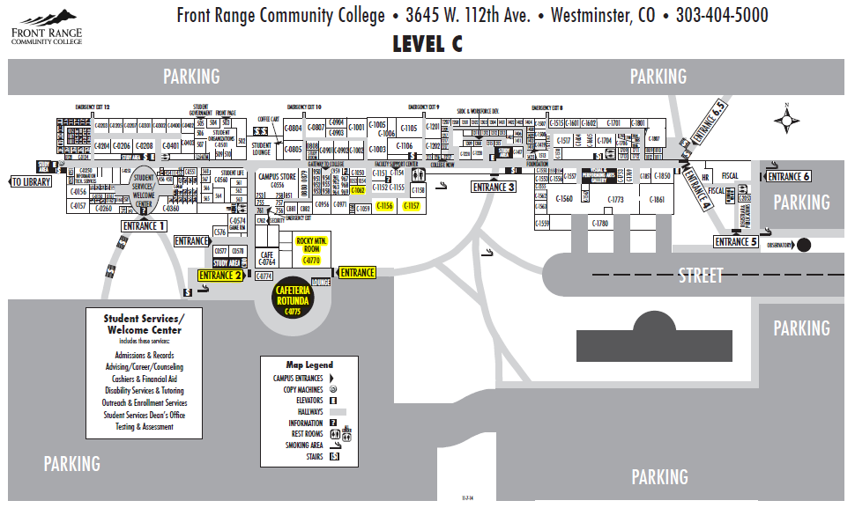



**Directions to Denver Marriott-Westminster**

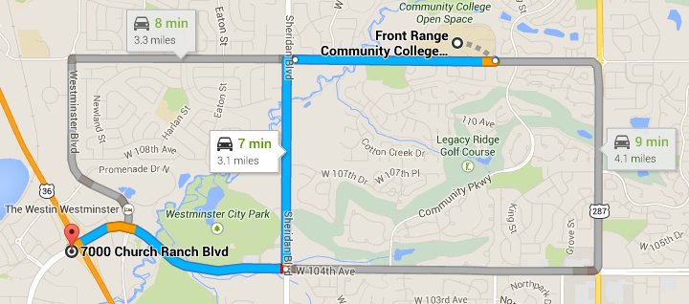

From the college parking lot, head south toward W 112th Ave. Turn right onto W 112th Ave and continue for 1.0 miles. Turn left onto Sheridan Blvd and continue for 1.0 miles. Turn right onto W 104th Ave and continue for 1.1 miles. The hotel is on your left after the U.S. 36 interchange.

include a map and directions to the social hour and/or the banquet facility. This was pulled directly from google maps.

**Future 2YC3 Conferences**

We encourage you to attend or present a paper at an upcoming conference. Please visit http://www.2yc3.org/php/meetings.php for the most current schedule of future conferences. Conference chairs are also needed for Spring 2017 and beyond. Contact the Future Sites Coordinator, Jason Jadin (futuresites@2yc3.org), for more information.

**Late Spring 2015**

May 22-23, 2015

210th Conference

Windward Community College

Honolulu, HI

Program Chair: Christopher Guay

cguay@hawaii.edu

**Early Fall 2015**

September 18-19, 2015

211th Conference

St. Charles Community College

Cottleville, MO

Contact: John Bookstaver

jbookstaver@stchas.edu

**Late Fall 2015**

November 6-7, 2015

212th Conference

Piedmont Virginia Community College

Charlottesville, VA

Contact: Barbara Heyl

bheyl@pvcc.edu

**2015 2YC3 Officers**

Abbreviated as COCTYC, the Committee on Chemistry in the Two-Year Colleges is designated as the executive committee governing the Two-Year College Chemistry Consortium and is charged with responsibility for three to four 2YC3 conferences per year and its own finances and newsletter.

|  |  |
| --- | --- |
| **Chair**  Scott Donnelly\*  Arizona Western College  chair@2yc3.org | **Treasurer**  Julie Ellefuson-Kuehn\*  Harper College  treasurer@2yc3.org |
| **Chair-elect 2015**  Tamika Duplessis\*  Delgado Community College  chairelect2015@2yc3.org | **Membership Chair/College Sponsors**  Tom Higgins  Harold Washington College  membership@2yc3.org |
| **Chair-elect 2016**  Kathy Carrigan  Portland Community College  chairelect2016@2yc3.org | **Industrial Sponsors Chair**  Michele Turner  University of Akron-Wayne College  industrialsponsors@2yc3.org |
| **Past Chair/DivCHED Representative**  Neil Bastian\*  Salt Lake City Community College  pastchair1@2yc3.org | **Newsletter Editor**  Jonathan Gittins\*  Delta College  newsletter@2yc3.org |
| **Past Chair/TAB Coordinator**  Pamela Clevenger  Itawamba Community College  tabchair@2yc3.org | **Webmaster**  Luca Preziati\*  Stark State College  webmaster@2yc3.org |
| **Past Chair/Future Sites Coordinator**  Jason Jadin\*  Rochester Community and Technical College  futuresites@2yc3.org | **Workshops Liaison**  Amy Jo Sanders\*  Stark State College  workshops@2yc3.org |

\*These officers are in attendance at the 209th conference.

**Notes**

|  |
| --- |
|  |
|  |
|  |
|  |
|  |
|  |
|  |
|  |
|  |
|  |
|  |
|  |
|  |
|  |
|  |
|  |
|  |
|  |
|  |
|  |
|  |
|  |
|  |
|  |

**Notes**

|  |
| --- |
|  |
|  |
|  |
|  |
|  |
|  |
|  |
|  |
|  |
|  |
|  |
|  |
|  |
|  |
|  |
|  |
|  |
|  |
|  |
|  |
|  |
|  |
|  |
|  |

**Notes**

|  |
| --- |
|  |
|  |
|  |
|  |
|  |
|  |
|  |
|  |
|  |
|  |
|  |
|  |
|  |
|  |
|  |
|  |
|  |
|  |
|  |
|  |
|  |
|  |
|  |
|  |

**Notes**

|  |
| --- |
|  |
|  |
|  |
|  |
|  |
|  |
|  |
|  |
|  |
|  |
|  |
|  |
|  |
|  |
|  |
|  |
|  |
|  |
|  |
|  |
|  |
|  |
|  |
|  |

**Notes**

|  |
| --- |
|  |
|  |
|  |
|  |
|  |
|  |
|  |
|  |
|  |
|  |
|  |
|  |
|  |
|  |
|  |
|  |
|  |
|  |
|  |
|  |
|  |
|  |
|  |
|  |

|  |  |  |  |  |  |  |  |
| --- | --- | --- | --- | --- | --- | --- | --- |
| [http://www.roch.edu/people/jjadin/2yc3-logo4.gif](http://www.2yc3.org/)  Insert  College Logo  First  Name  College  City, State | |  |  | | --- | --- | | [Description: http://www.roch.edu/people/jjadin/2yc3-logo4.gif](http://www.2yc3.org/)  First  Insert  College Logo  Name  College  City, State |  | |  |  | |  |  | |
| |  |  |  |  | | --- | --- | --- | --- | | [Description: http://www.roch.edu/people/jjadin/2yc3-logo4.gif](http://www.2yc3.org/)  Insert  College Logo  First  Name  College  City, State | |  | | |  | |  | | |  | |  | | | [Description: http://www.roch.edu/people/jjadin/RCTClogo.gif](http://www.rctc.edu/)[Description: http://www.roch.edu/people/jjadin/2yc3-logo4.gif](http://www.2yc3.org/)  Jason  Jadin  Rochester Community & Technical College  Rochester, MN | |  | | |  | |  | | |  | |  | | | |  |  | | --- | --- | | [Description: http://www.roch.edu/people/jjadin/2yc3-logo4.gif](http://www.2yc3.org/)  First  Insert  College Logo  Name  College  City, State |  | |  |  | |  |  | |
| |  |  | | --- | --- | | [Description: http://www.roch.edu/people/jjadin/2yc3-logo4.gif](http://www.2yc3.org/)  First  Insert  College Logo  Name  College  City, State |  | |  |  | |  |  | | |  |  | | --- | --- | | [Description: http://www.roch.edu/people/jjadin/2yc3-logo4.gif](http://www.2yc3.org/)  First  Insert  College Logo  Name  College  City, State |  | |  |  | |  |  | |

Double click to open Excel Workbook.



**Directions from RCTC to Social Mixer/Dinner Banquet at the Doubletree Plaza Hotel**

1. From the UCR parking lot, turn right onto County Road 22 (30th Ave SE).

2. At the stoplight, turn right onto US Hwy 14 (12th St SE) and continue for 2.2 miles.

3. Make a slight right and merge onto US Hwy 63 (S. Broadway) and continue for 1.1 miles.

4. The Doubletree Plaza Hotel is located at 150 S. Broadway. Please park in the city parking ramps located directly behind the hotel. Parking in city ramps is free if you enter after 5:00 p.m.

5. The social mixer and banquet will be held in the Galleria III-IV Ballroom.

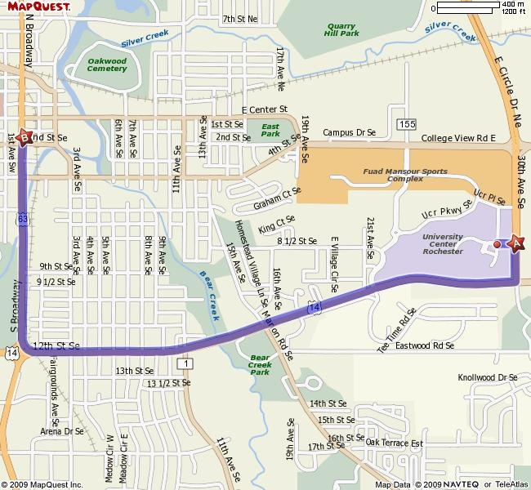

March 8, 2016

This receipt acknowledges that has attended the XXXXX Two-Year College Chemistry Consortium (2YC3) Conference in **City, State** on **Dates**. The following payments were received.

$40 Conference Early Registration Fee

$50 Conference Late Registration Fee

$25 2YC3 Membership Fee

$**??** Friday Lunch Fee

$**??** Friday Banquet Fee

$**??** Saturday Lunch Fee

**Total Payment $**

**Your Name**

Program Chair

**2009 2YC3 Officers**

Abbreviated as COCTYC, the **Committee on Chemistry in the Two-Year Colleges** is designated as the executive committee governing the Two-Year College Chemistry Consortium and is charged with responsibility for three to four 2YC3 conferences per year and its own finances and newsletter.

**Chair**

\*Candice McCloskey-Campbell

Georgia Perimeter College-Dunwoody

chair@2yc3.org

**Chair-elect**

\*Lance Lund

Anoka-Ramsey Community College

chairelect@2yc3.org

**Past Chair/DivCHED Representative**

Jeffery Cramer

Stark State College of Technology

pastchair1@2yc3.org

**Chair-elect 2010**

Mark Matthews

Durham Technical College

chairelect2@2yc3.org

**Past Chair/RAB Coordinator**

\*Michaeleen Lee

Bucks County Community College

pastchair2@2yc3.org

rabcoordinator@2yc3.org

**Past Chair/Future Sites Coordinator**

\*Dolores Aquino

San Jacinto College Central

pastchair3@2yc3.org

futuresites@2yc3.org

**Treasurer**

\*Kelly Befus

Anoka-Ramsey Community College

treasurer@2yc3.org

**Membership Chair/College Sponsors**

\*Frank Randayal

Bergen Community College

membership@2yc3.org

collegesponsor@2yc3.org

**Industrial Sponsors Chair**

\*Michele Turner

University of Akron-Wayne

industrialsponsors@2yc3.org

**Newsletter Editor**

James Schneider

Portland Community College

newsletter@2yc3.org

**Webmaster**

\*Andy Aspaas

Anoka-Ramsey Community College

webmaster@2yc3.org

\*These officers are in attendance at the 185th conference

Future 2YC3 Meetings

We encourage you to attend or present at an [upcoming conference](http://webs.anokaramsey.edu/2yc3/Meetings/default.htm). Conference chairs are also needed for Spring 2011 and beyond. Contact Future Sites Coordinator Dolores Aquino, [futuresites@2yc3.org](mailto:futuresites@2yc3.org), for more information.

Late Fall 2009

Nov 13-14, 2009

186th Conference (Southern)

Hinds Community College

Raymond, MS

Program Chair: Pam Clevenger

pwclevenger@hindscc.edu

Spring 2010

March 19-20, 2010

187th Conference (Western)

City College of San Francisco

(Preceding the Spring San Francisco ACS Meeting)

Contact: Bob Price

rprice@ccsf.edu

Summer 2010

188th Conference, 21st BCCE

University of North Texas

Denton, TX

http://www.bcce2010.org/

Early Fall 2010

September 10-11, 2010

189th Conference (Eastern)

Portland Community College (tentative)

Portland, OR

Contact: Jim Schneider

[jschneid@pcc.edu](mailto:jschneid@pcc.edu)

**Directions from Hotel to RCTC**

1. Drive south on Broadway (US Hwy 63) for 1.1 miles

2. Turn left onto US Hwy 14 (12th St SE) and continue for 2.2 miles.

3. Turn left onto County Road 22 (30th Ave SE). Drive for about 250 feet and turn left into the University Center Rochester (UCR) campus.

4. Please park in the East Student/Visitor parking lot. No parking permit is required. Please do not park in the faculty parking area or a metered space. If the East lot is full, then you may park in the North Student/Visitor parking lot by the Regional Sports Center.

5. Follow the signs to the Atrium Building (doors 13a-e). The registration will be located just inside the Atrium doors.



**Campus and Building Maps**

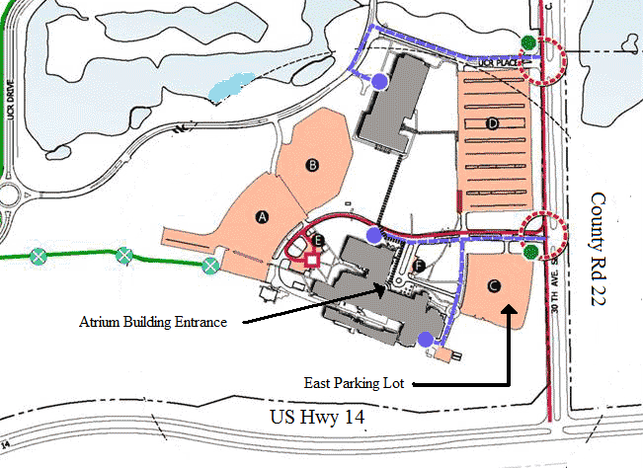

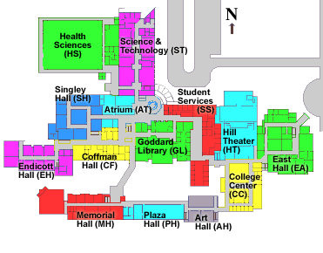



Restaurant Guide

1. Chester’s (American cuisine)

Shoppes at University Square

2. City Café (American cuisine)

216 1st Ave SW

3. Twig’s (American Cuisine)

401 6th St SW

4. Michael’s (Steaks)

15 S. Broadway

5. Jaspers (European cuisine)

14 3rd St SW

6. Victoria’s (Italian cuisine)

7 1st Ave SW

7. Whistle Binkie’s (Bar Food)

247 Woodlake Dr SE

8. Redwood Room (American cuisine)

300 1st Ave SW

9. Newt’s (Bar Food)

216 ½ 1st Ave SW

10. Pescara (Sea food)

150 S. Broadway

11. Sushi Itto (Japanese)

318 S. Broadway

12. Bilotti’s (Pizza)

304 1st Ave SW

13. Pho Hoa (Vietnamese)

1726 37 St NW

14. Food Court at Shoppes at University Square





Restaurant Guide

1. Chester’s (American cuisine)

Shoppes at University Square

2. City Café (American cuisine)

216 1st Ave SW

3. Twig’s (American Cuisine)

401 6th St SW

4. Michael’s (Steaks)

15 S. Broadway

5. Jaspers (European cuisine)

14 3rd St SW

6. Victoria’s (Italian cuisine)

7 1st Ave SW

7. Whistle Binkie’s (Bar Food)

247 Woodlake Dr SE

8. Redwood Room (American cuisine)

300 1st Ave SW

9. Newt’s (Bar Food)

216 ½ 1st Ave SW

10. Pescara (Sea food)

150 S. Broadway

11. Sushi Itto (Japanese)

318 S. Broadway

12. Bilotti’s (Pizza)

304 1st Ave SW

13. Pho Hoa (Vietnamese)

1726 37 St NW

14. Food Court at Shoppes at University Square



C:\Program Files\Microsoft Office\MEDIA\OFFICE12\Lines\BD21315_.gif

***Program Summary***

***Friday, September 25***

8:00 – 9:00 Registration

9:15 – 10:15 Keynote Presentation

10:45 – 11:15 Membership Meeting

11:20 – 12:00 Presentation Sessions

12:00 – 1:00 Lunch

1:00 – 5:30 Presentation Sessions

5:45 – 6:30 Social Mixer

6:30 – 8:00 Banquet and Speaker

***Saturday, September 26***

9:00 – 10:00 Opening Speaker

10:30 – 12:00 Presentation Sessions

12:00 – 1:00 Lunch

1:00 – 3:20 Presentation Sessions

3:45 – 5:00 Demonstration Show

C:\Program Files\Microsoft Office\MEDIA\OFFICE12\Lines\BD21315_.gif

C:\Program Files\Microsoft Office\MEDIA\OFFICE12\Lines\BD21315_.gif

***Program Summary***

***Friday, September 25***

8:00 – 9:00 Registration

9:15 – 10:15 Keynote Presentation

10:45 – 11:15 Membership Meeting

11:20 – 12:00 Presentation Sessions

12:00 – 1:00 Lunch

1:00 – 5:30 Presentation Sessions

5:45 – 6:30 Social Mixer

6:30 – 8:00 Banquet and Speaker

***Saturday, September 26***

9:00 – 10:00 Opening Speaker

10:30 – 12:00 Presentation Sessions

12:00 – 1:00 Lunch

1:00 – 3:20 Presentation Sessions

3:45 – 5:00 Demonstration Show

C:\Program Files\Microsoft Office\MEDIA\OFFICE12\Lines\BD21315_.gif

Dear ???,

This is to confirm receipt of your registration for the conference to be held on **Date** at **Name of College.**

I have received payment for:

Registration fee for non-current 2YC3 member: $50

Friday Lunch: $10

Friday Banquet: $25 (**meal option**)

Saturday Lunch: $10

I'm looking forward to meeting you and if I can help you in any way with your travel arrangements please let me know.

**Example letter/email to current industrial sponsors inviting them to exhibit.**

(Change the date and feel free to change anything to fit your plans or style better, etc.)

June 21, 2009

To: All Industrial Sponsors of 2YC3

From: Teresa Brown, exhibits coordinators

As perhaps you know, the second fall conference of the Two-Year College Chemistry Consortium (2YC3) is set for September 25-26*,* 2009, at Rochester Community & Technical College. We have a full program planned (see http://2yc3.org) and expect that the conference will be well-attended. I would like to personally invite you to exhibit at this conference. We have very good facilities for the exhibit area and it is very close to the rooms where the presentations and workshops will be held. I am sure that your company will receive significant positive exposure to all conference attendees.

Please contact either Jason Jadin or Teresa Brown (at [jason.jadin@roch.edu](mailto:jason.jadin@roch.edu) and [teresa.brown@roch.edu](mailto:teresa.brown@roch.edu), respectively.)if you do in fact plan to exhibit or if you have any questions. I am enclosing (attaching) an Exhibit Request Form for you to fill out and return to me. You can plan to send your exhibit materials to me in advance of the conference so that everything will be ready for you when you arrive. My address at the college is:

Teresa Brown

Rochester Community & Technical College

851 30th Ave SE  
Rochester, MN 55904-4999.

Sincerely,

Jason Jadin and Teresa Brown

March 8, 2016

To: \_\_\_\_\_\_\_\_\_\_\_\_\_\_\_\_\_\_\_\_\_\_\_\_\_\_\_\_

From: Name of Exhibits Coordinator, **College Name**

As a manufacturer (or distributor, or \_\_\_\_\_\_\_\_\_\_\_\_\_\_\_) of \_\_\_\_\_\_\_\_\_\_\_\_\_\_\_\_\_\_\_\_\_\_ , you may have a special interest in reaching out to two-year college chemistry faculty. If this is true, then I would like to invite you to exhibit at our upcoming national conference of two-year college chemistry faculty to be held **Date** at **Name of College**. The conference is organized by the Two-Year College Chemistry Consortium (2YC3) with the cooperation of local faculty members here at **Name of College**.

The charge for exhibiting is $200. Besides allowing you to exhibit at the **XXXxx** 2YC3 conference, payment of this fee means that you become an “industrial sponsor” of 2YC3 for one year and that, in turn, means that your company name will be added to the current published list of sponsors and you will be eligible to exhibit at two additional conferences of this organization held at various locations around the country. The sponsorship is renewable each year for the same $200 fee. The published list appears on the 2YC3 web site, <http://2yc3.org>, as well as regularly in the 2YC3 newsletter, which is mailed to all members, industrial sponsors, and advertisers four times a year.

Please visit the 2YC3 web site where you can view the program for the upcoming conference and also view the list of current sponsors, some of which may be your competitors. If you think that this sponsorship is something you would like to try, please contact me. My email address is \_\_\_\_\_\_\_\_\_\_\_\_\_\_\_\_\_ and my telephone number is \_\_\_\_\_\_\_\_\_\_\_\_\_\_\_\_\_. You may also contact the national 2YC3 Industrial Sponsor Chair, Michele Turner, [cmt@uakron.edu](mailto:cmt@uakron.edu). Thank you.

Sincerely,

Hi,

It’s hard to believe that the 209th conference is only a few weeks away!

If you are shipping material to the college, please send them to:

**Name (Exhibits Coordinator)**

**Department of Chemistry**

**College Name**

**College Address (Street)**

**City, State, Zip Code**

Material sent should be clearly marked **"EXHIBIT MATERIAL FOR TWO-YEAR COLLEGE CHEMISTRY CONFERENCE--DELIVER UNOPENED TO ADDRESSEE"**. All such material should be preceded by a separate cover letter indicating the number of boxes or items to be expected.

You will be able to start setting-up your tables at around 7:00 a.m. on Friday.  Exhibits will be in the Rocky Mountain Room (C-0770) at Front Range Community College – Westminster Campus.  Your tables will be set-up around the perimeter of the room.  The middle of the room will have table rounds for general seating and eating.  The refreshments table will also be in the Rocky Mountain Room (nothing draws people into the exhibits rooms better than food).  I will have signs on the tables indicating which table is yours.  It will probably be in alphabetical order.  I will also have conference folders with you name badges, conference program, and meal tickets (if ordered) on the tables.

[Directions to FRCC-Westminster Campus.](https://www.google.com/maps/dir/Front+Range+Community+College+-+Westminster+Campus,+3645+West+112th+Avenue,+Westminster,+CO+80031/@39.921446,-104.977692,11z/data=!4m8!4m7!1m0!1m5!1m1!1s0x876b8a05dfb658a5:0x9c44d055089c9189!2m2!1d-105.037804!2d39.900936?hl=en-US)

[209th Conference Website.](http://www.roch.edu/people/jjadin/209%20files/209.html)

Let me know if you have questions.

****

**209th 2YC3 Conference**

***Chemistry Education Resources***

**March 20-21, 2015**

**Front Range Community College – Westminster Campus**

**3645 West 112th Avenue**

**Westminster, CO 80031**

**Call for Papers**

We invite you to attend the 209th 2YC3 Program on March 20-21, 2015. The conference will take place at Front Range Community College – Westminster Campus, located in the greater Denver area. We currently are looking for colleagues who would like to contribute to our program by giving a presentation, leading a workshop, or participating in a panel discussion. We especially encourage topics related to our theme “Chemistry Education Resources”. If you would like to present on a different topic, please do not hesitate to submit an abstract, as we encourage as diverse a program as possible. The due date for submitting abstracts is March 6th, 2015.

**Program Highlights**

The first keynote speaker is Wayne E. Jones Jr. He is a professor and chair of the chemistry department at SUNY Binghamton. He has been the recipient of the Chancellor’s Award for Excellence in Teaching. As Director of the Center for Learning and Teaching, Dr. Jones' teaching interests concentrate on the effective use and evaluation of technology in the classroom. These teaching interests involve long-term curriculum development in chemistry including more expanded use of technology in introductory chemical education, use of interactive multi-media materials for self-directed learning, and the design of new advanced undergraduate laboratories based on the guided inquiry approach.

The second keynote speaker is Jerry Suits, an associate professor from the University of Northern Colorado. Dr. Suits' research focuses on the factors that affect how students learn chemistry. Currently, he is studying (a) how motivation and cognitive factors affect chemistry achievement, and (b) how interactive computer technology can stimulate active learning and developing thinking strategies that rely on visualization and other mental processes. His presentation is entitled, “Dynamic Visualizations and Student Conceptual Understanding of Chemistry Topics.”

Other scheduled presentations include a panel discussion on the “Chemistry Textbook of the Future.” The ACS will conduct a workshop entitled, “Get a Jump Start Using the ACS Assessment Tool for Chemistry in Two-Year College Programs.”

**Travel/Directions**

Denver International Airport (DEN) is the closest major airport to the conference venue and is served by all major airlines. Car rental, private shuttles, and taxicabs are available at the airport. Front Range Community College is located on 112th Street off Highway 36, Westminster exit.

**Lodging**

The Denver Marriott Westminster is accommodating 2YC3 travels with a special rate of $119 (plus tax). The Marriott hotel is also the site of the Friday night social hour and banquet. On-line reservations should be made using the link on the conference website. Phone reservations should be made by calling 720-887-1177 and asking for the 2YC3 room rate.

**Registration and Conference Website**

Registration and up-to-date conference information can be found at the website listed below or by scanning the QR code.

<http://www.2yc3.org/php/meetings.php>

**Contacts**

Dr. Denis Kissounko – Program Chair

denis.kissounko@arapahoe.edu

303-664-0394 ext 166

Jason Jadin – Local Arrangements/Exhibits Chair

jason.jadin@rctc.edu

507-285-7299

****

**209th 2YC3 Conference**

**Conference Announcement**

**Call for Papers**

***Chemistry Education Resources***

**March 20-21, 2015**

**Front Range Community College – Westminster Campus**

**3645 West 112th Avenue**

**Westminster, CO 80031**

We currently are looking for colleagues who would like to contribute to our program by giving a presentation, leading a workshop, or participating in a panel discussion. We especially encourage topics related to our theme “Chemistry Education Resources”. If you would like to present on a different topic, please do not hesitate to submit an abstract, as we encourage as diverse a program as possible. The due date for submitting abstracts is March 2nd, 2015.

Please visit the 209th conference website at a later date for more information about the program, lodging, directions, and sponsors.

**Conference Chairs**

Denis Kissounko denis.kissounko@arapahoe.edu

Jason Jadin jason.jadin@rctc.edu

Catering Bid for 75 attendees on Friday

