PLEASE JOIN US FOR THE CLOSING PRESENTATION,

SATURDAY 04/01, 2:35-3:20 p.m. Student Center

“That Won’t Work”: Creating Cultures of Innovation in the Community College

Presented by: Dr. Jill Channing, TMCC Dean of Liberal Arts
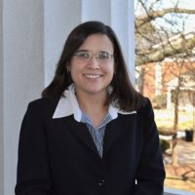

How do you know if something is “innovative”? What does it mean to be an “innovative educator”? We will discuss specific strategies for faculty, administrators, and staff at community colleges to create cultures that lead to innovations in the classroom and in the operations of the college, using resilience, collaboration, growth mindsets, and the language of innovation. Although we can adapt successful strategies others have used to our own contexts, we should not limit themselves to “tried” strategies but should take risks and learn from successes and failures to develop new strategies and processes.
Biography:

Dr. Jill Channing serves as Dean of Liberal Arts at Truckee Meadows Community College. Prior to coming to TMCC, she was Associate Dean of Humanities and Social Sciences at Kankakee Community College in Kankakee, IL and served previously as Director of Writing Programs and English Department Chair at Mitchell Community College in Statesville, NC. She has over a decade of experience leading academic departments and teaching writing, literature, and women’s and gender studies courses. She earned a B.A. and an M.A. in English from Wright State University in Dayton, OH. Channing also holds a Ph.D. in Educational Leadership and Cultural Studies from the University of North Carolina at Greensboro. Channing has published numerous articles and presented on various topics related to teaching writing and literature, culture and education, and higher education leadership.

